Promethous

Proemthus pull metrics from aws 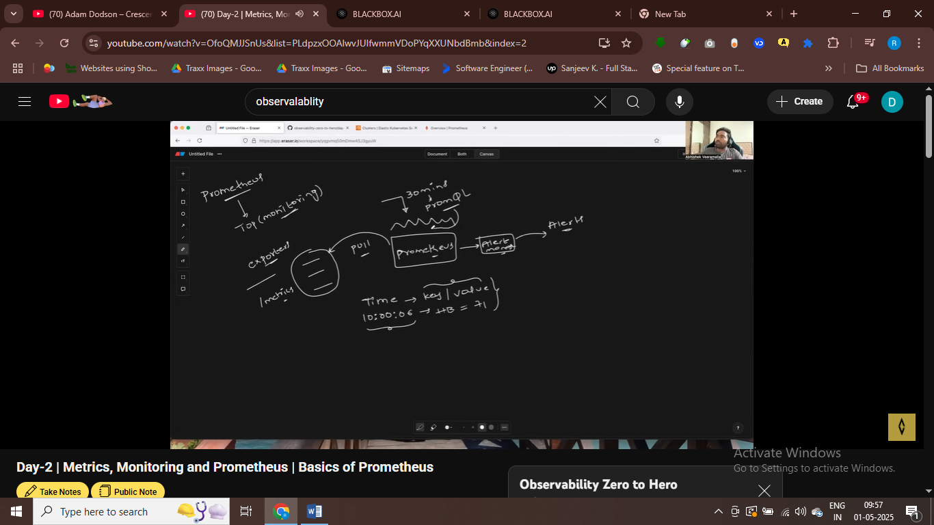

And after geeting metrics we can send alers

Only read metics form 20 service

We use service discrovery for it – to collect metircs from 20 service

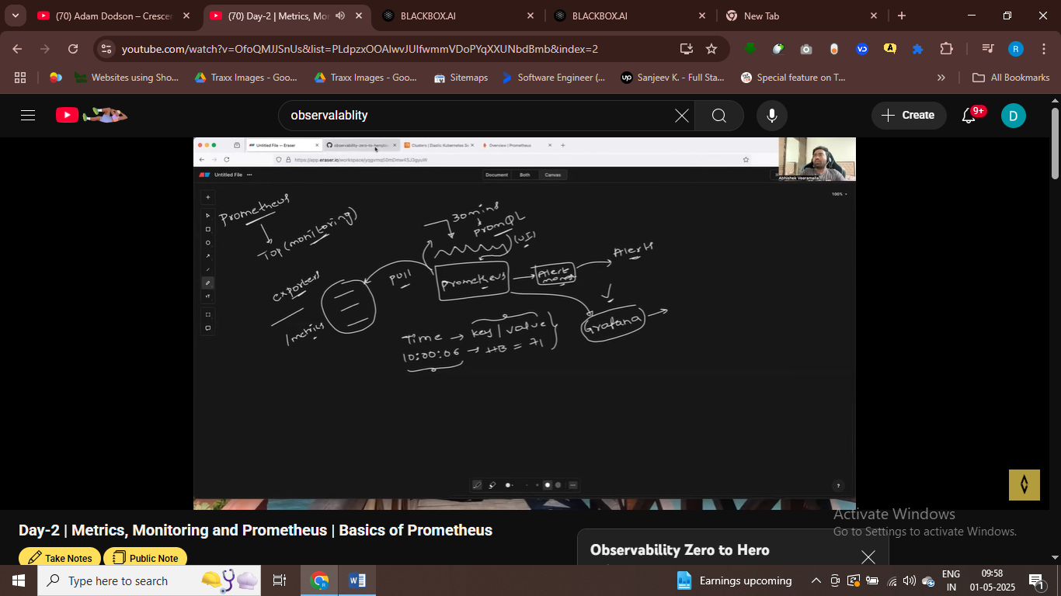

Grafana is very rich in dashboard

Both work together

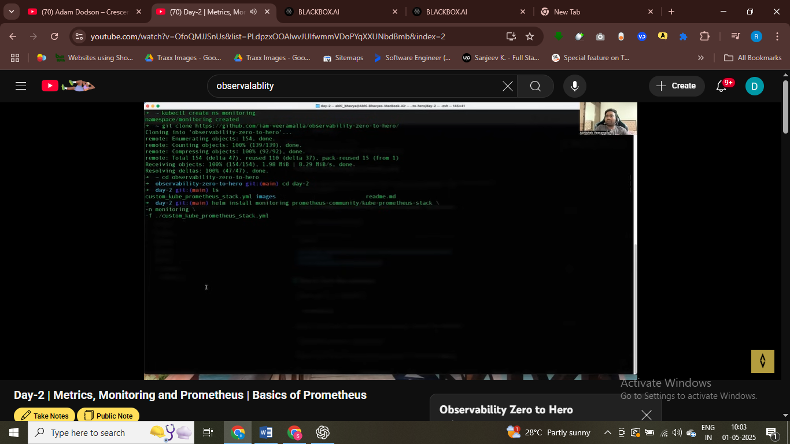

# install promenthous on EKS clusters

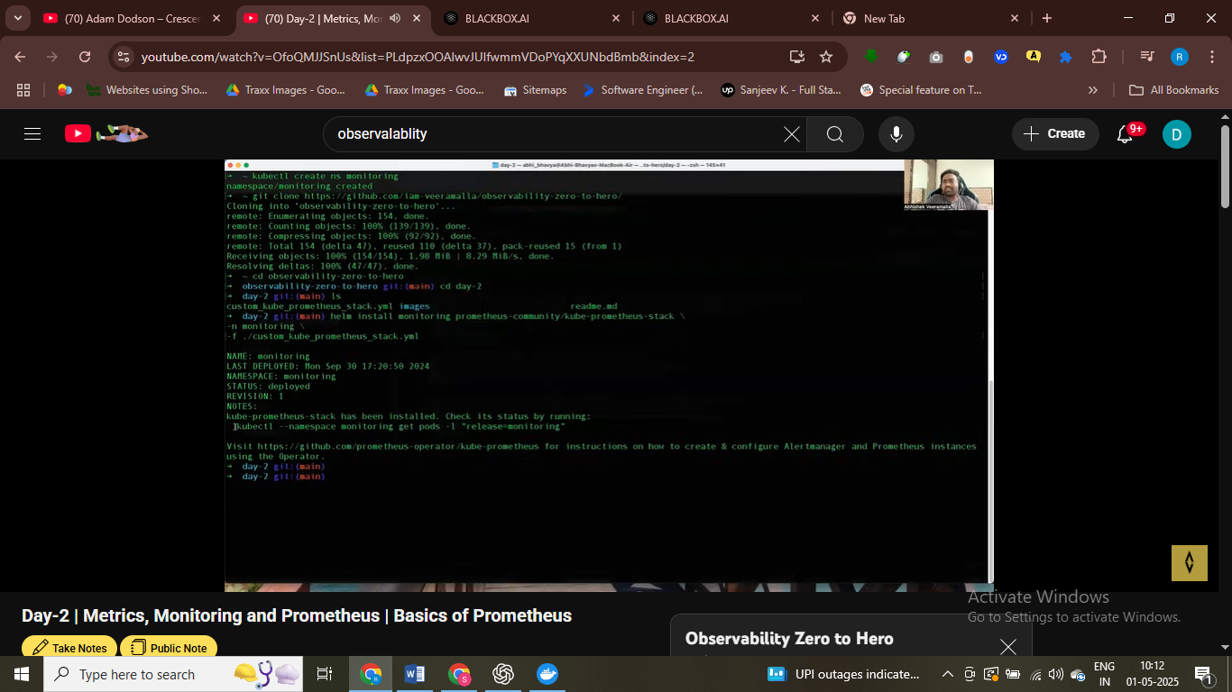

# promethous install

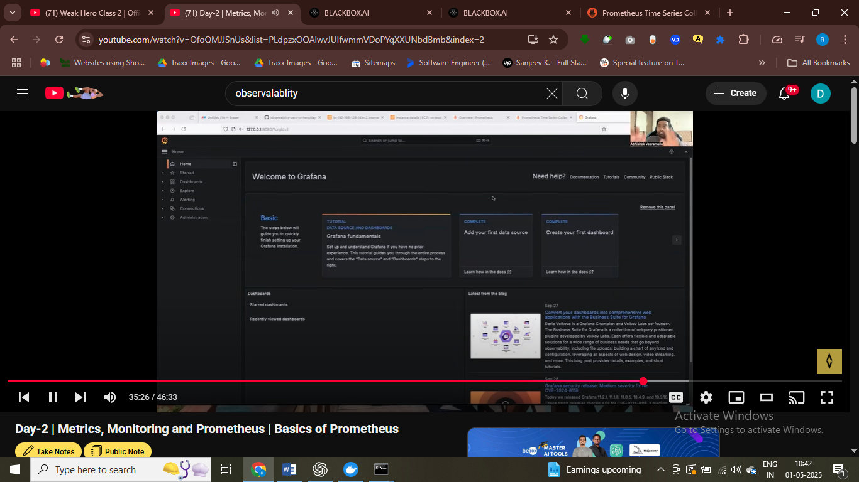

Access grafana

Grafana for to see dashboard

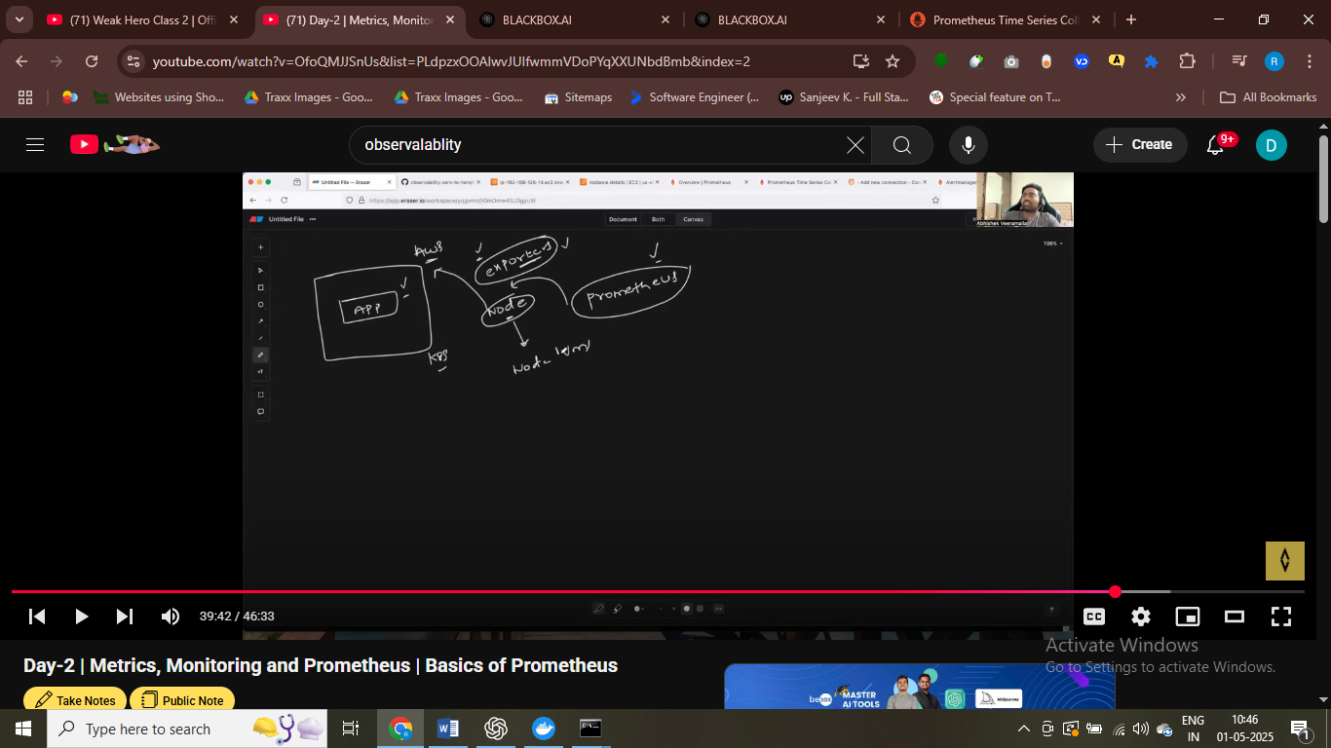

Prpomenthous have exporter which is node exporter , to collect about node metircs

+

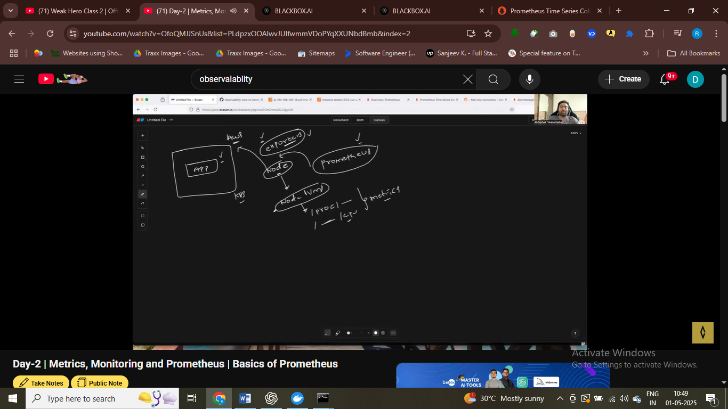

Promenthous pull these metrics form node exposerte using node exprted

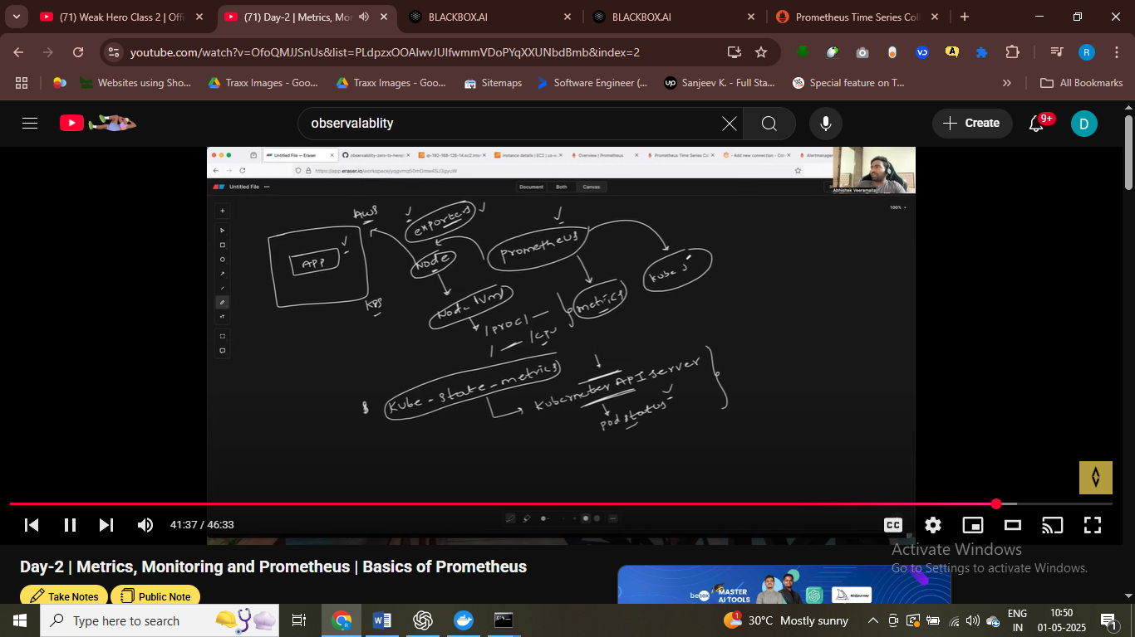

It communicate thorugh kube – api server , collect pod metrics deployment

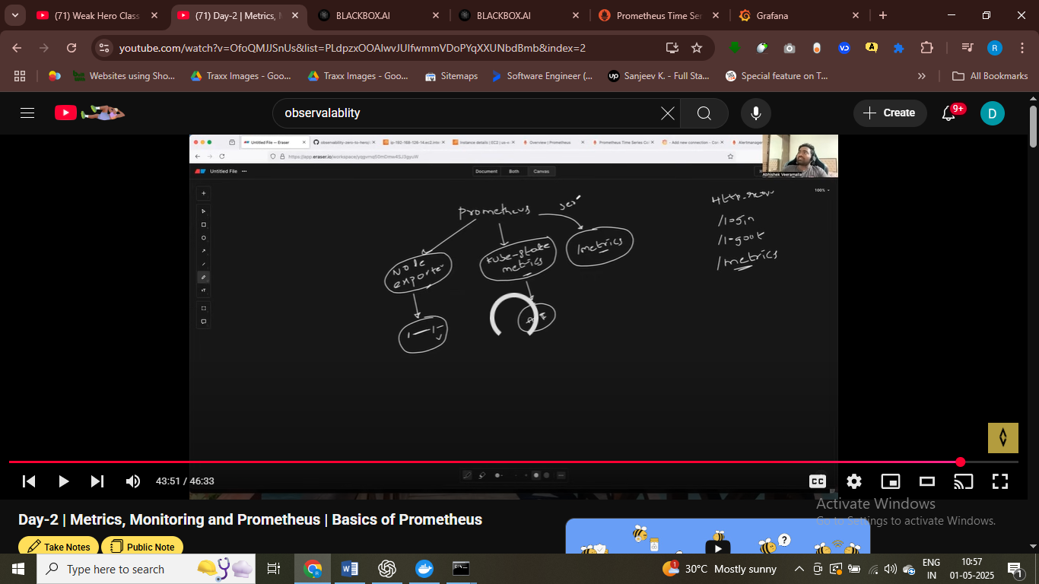

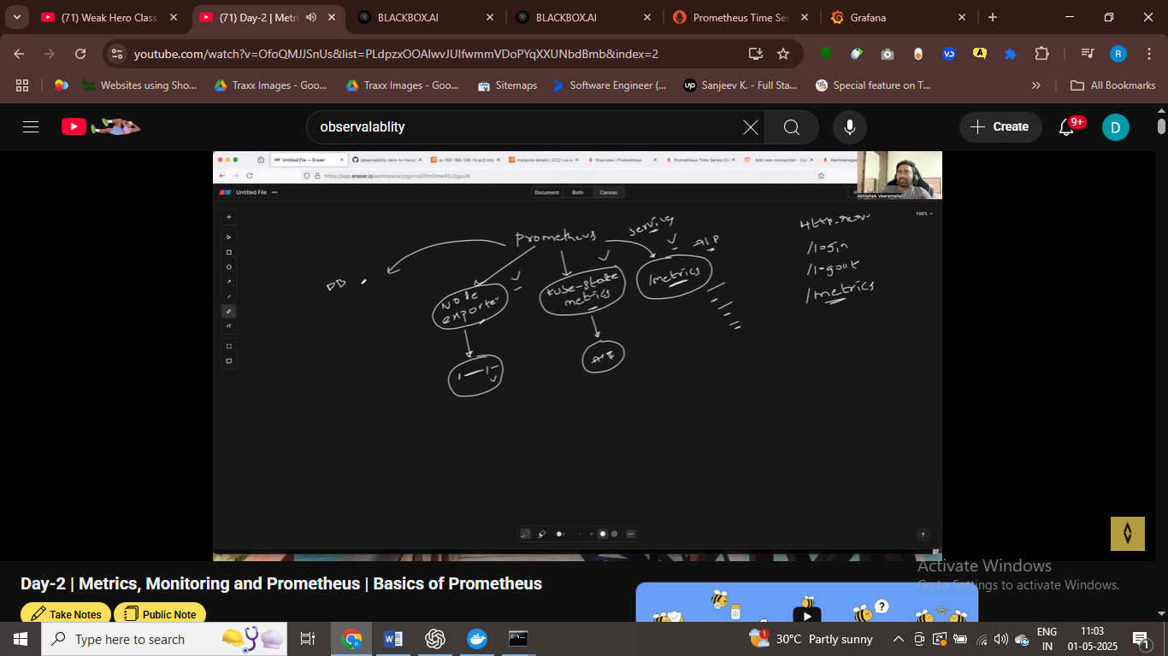

# check metrics

We have node= exporter for geeeting metrics of node

Kube-state metircs

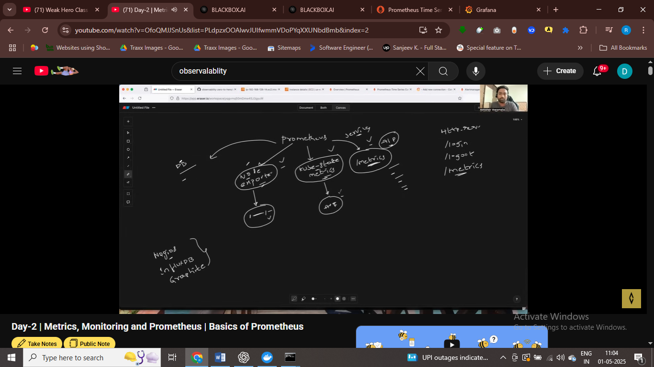

Cncf project proemthous – Nagios cometitior of promenthous , influxDB competitor of promenthous

Proemethous it scarepe the metrics

Promenthosu scrape the metrics from node exporter

Promethous scrape the metrics from kube state metrics

Kube state talk to kube api server and get metrics from it related to pod infor , deployment and all

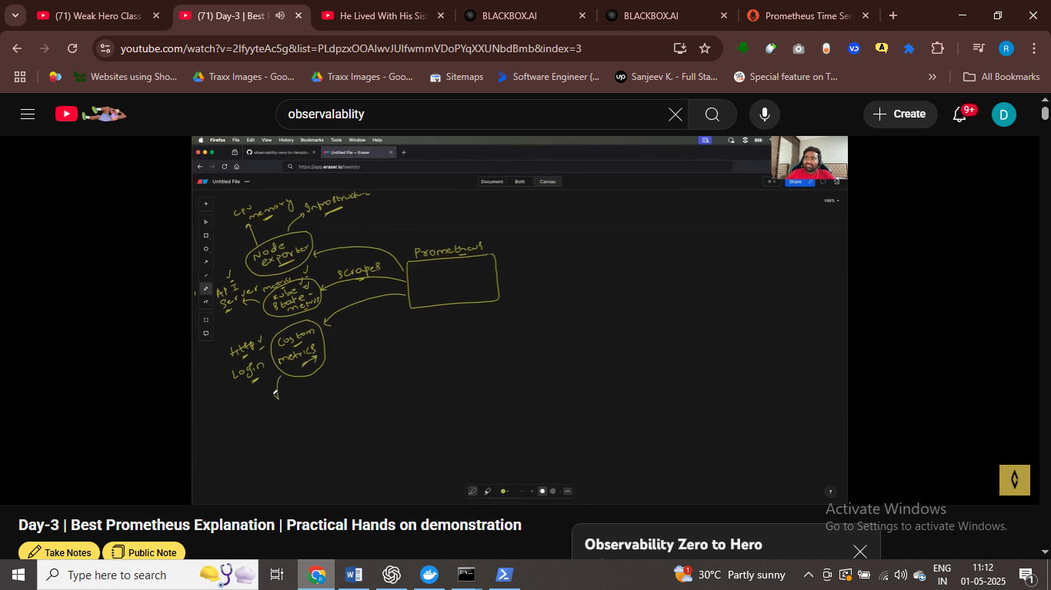

These are primary seouces from promenthous scrape the metrics

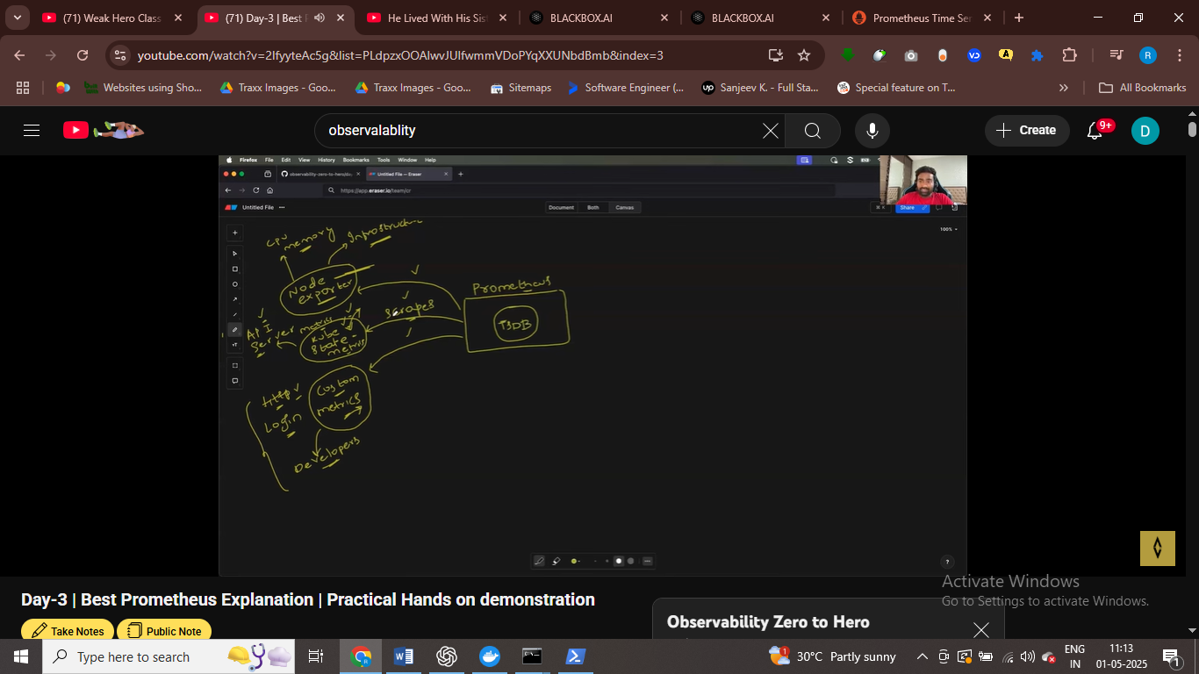

Promenthous scrape these metrics and store in time series data bse

Thse are pillar of promethous

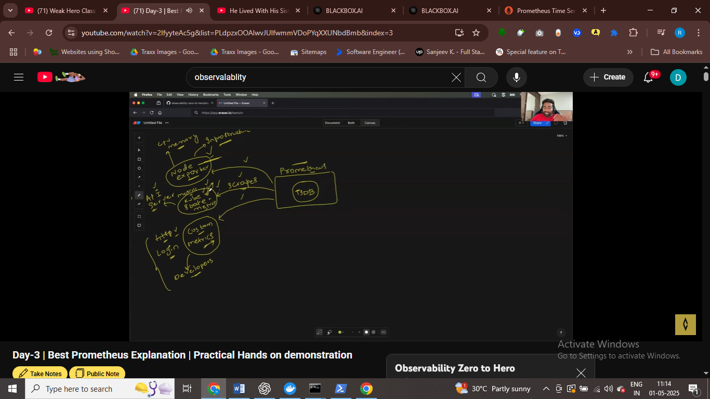

We have mysql exporter to collect metrics from mysql

It is storing in all time series data , you store metrics but we also record time of that metric when it is stored in time series data.

User write promql queries and get the output in graph format

Alert manager = if utilization excedd then we can send alert

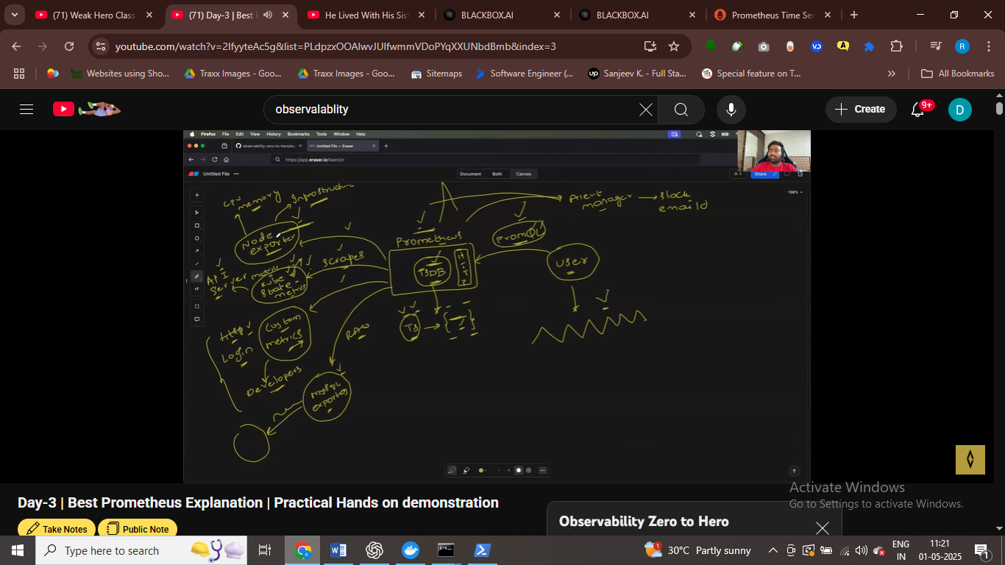

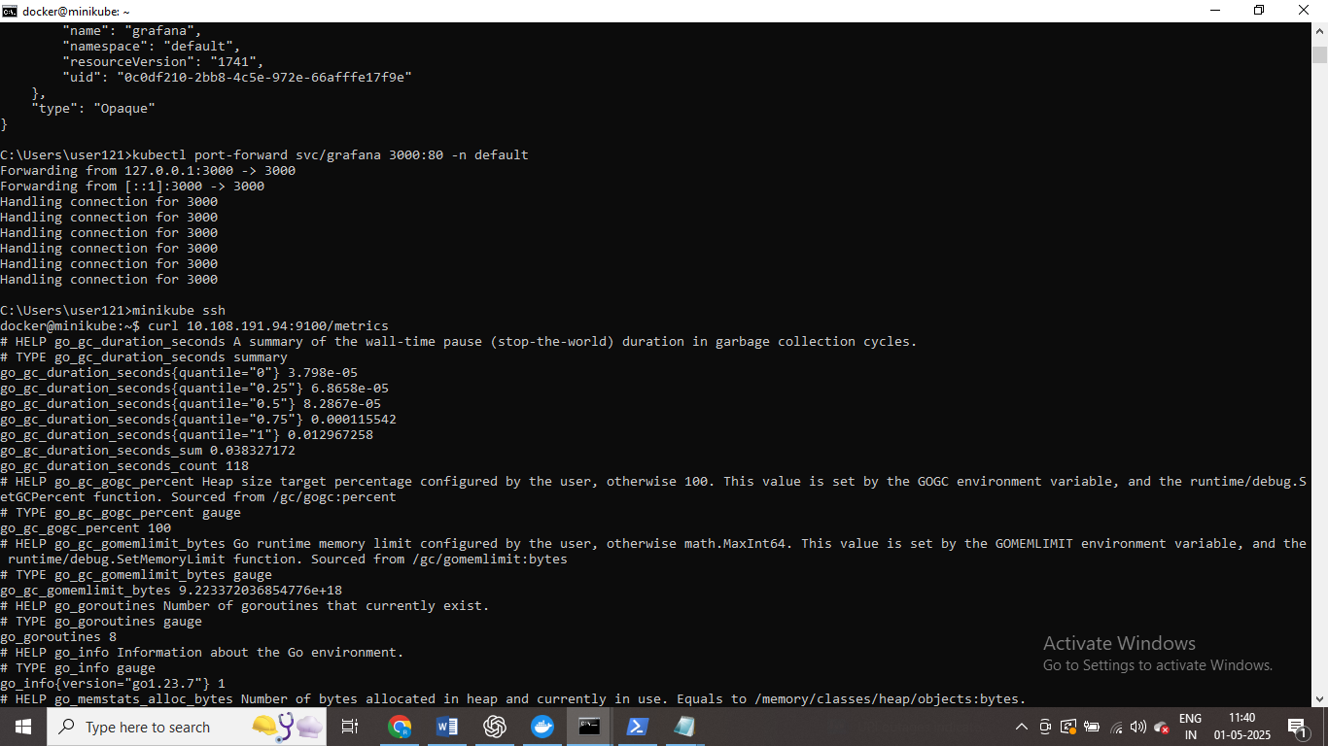use node expoerted ip – and this is how node expoerted collectiong metrics ,

* And promenthous geeting metrics form node –expoerter

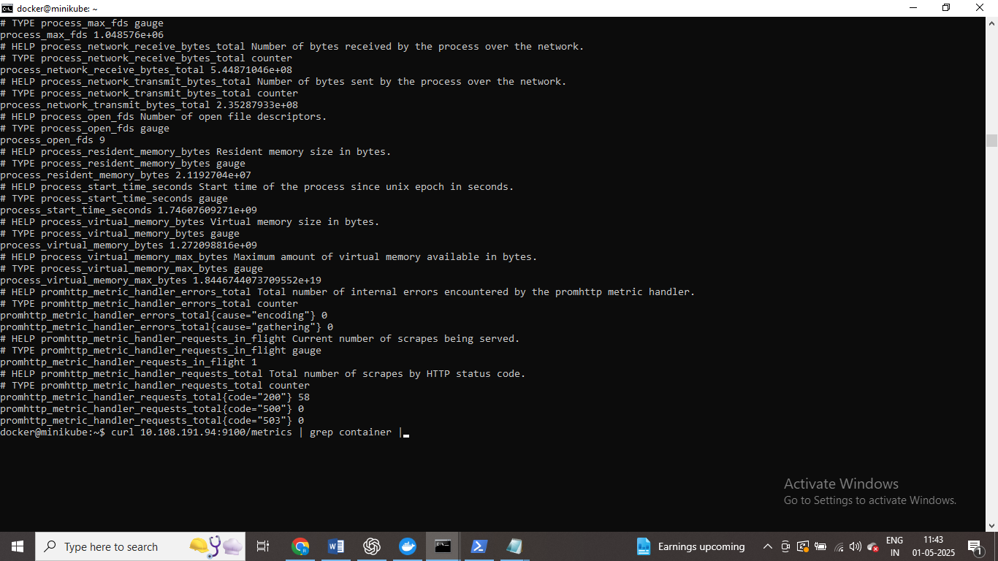

Info about container using node exporter ip

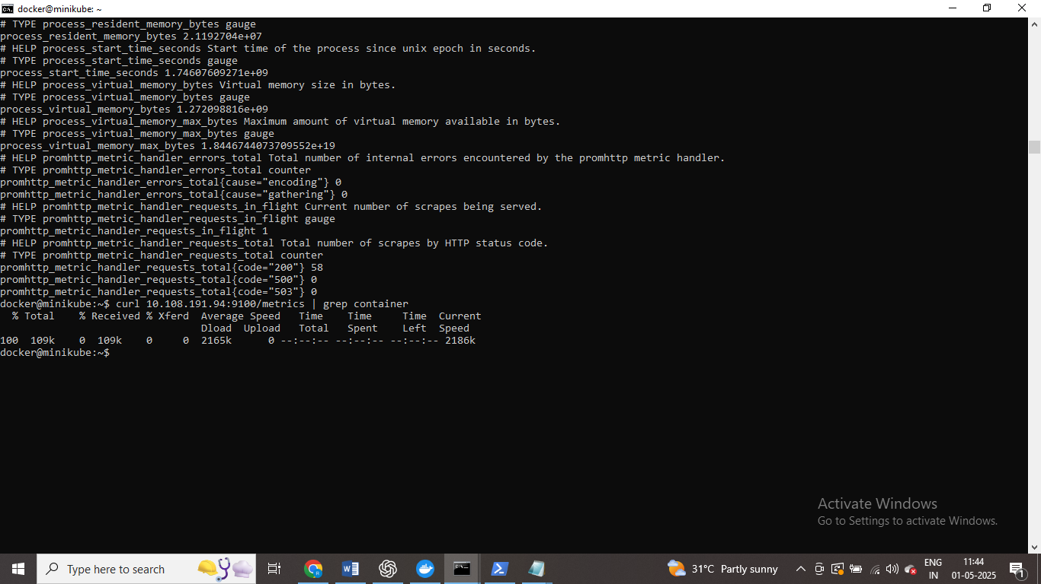

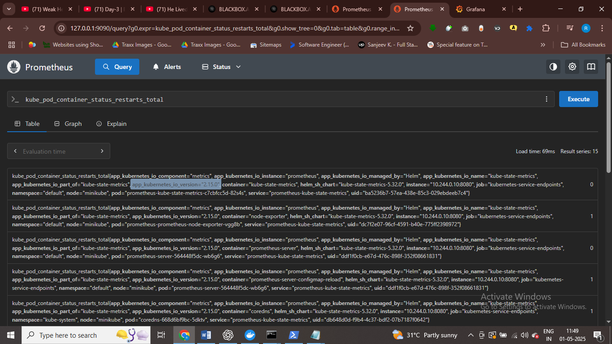this is a metric we have

How many time the container restarting and how many time in all the namespace

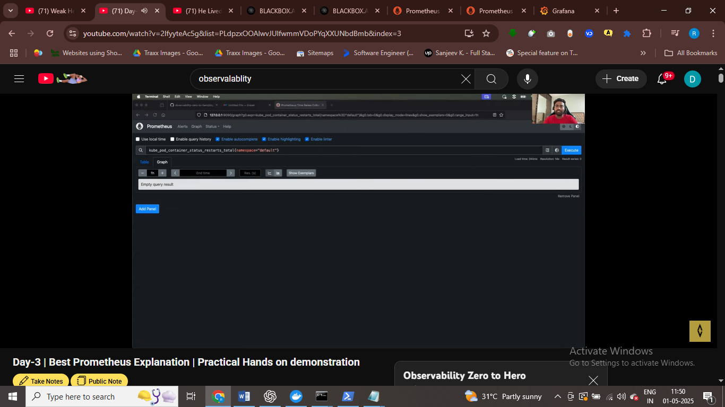

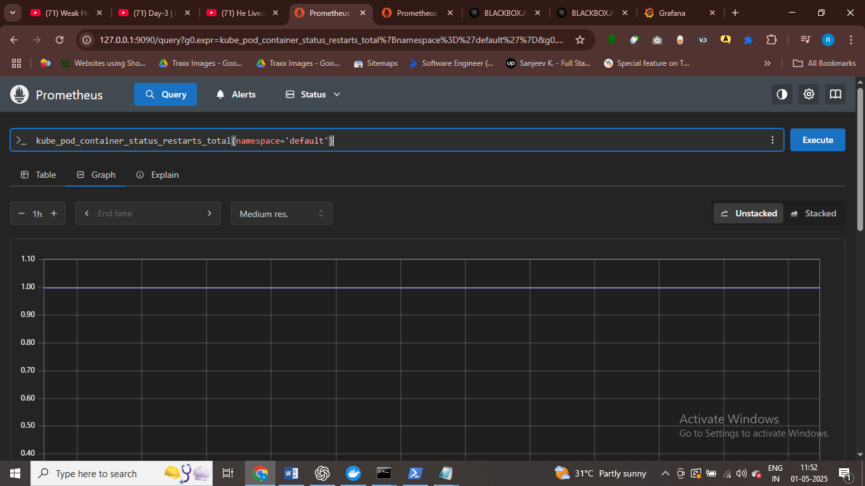

# inside default this is running and collecting metrics about them

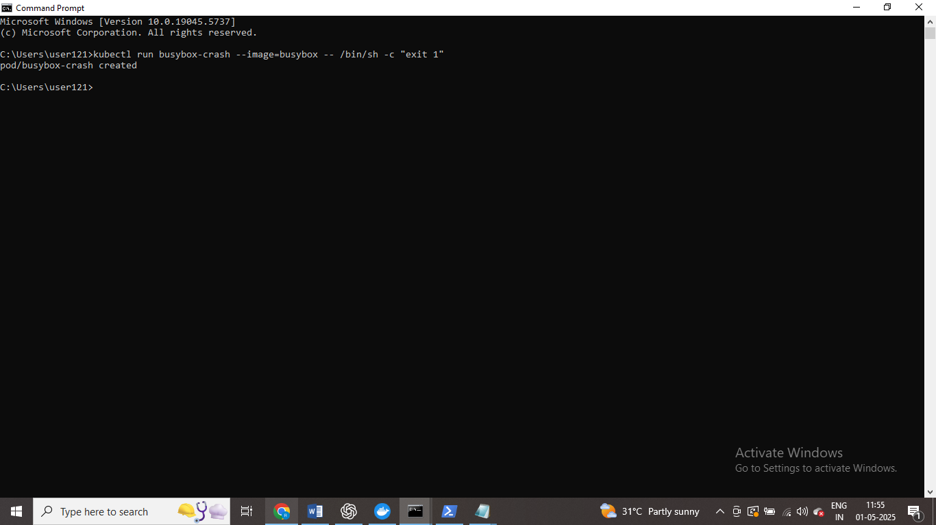a pod that always cash and I want to see it in proemthous

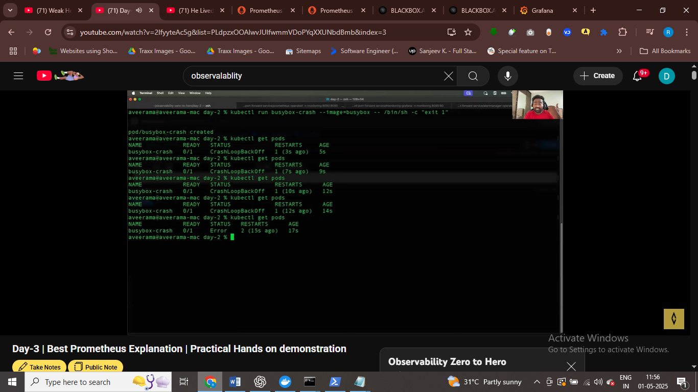

# pod crash twice

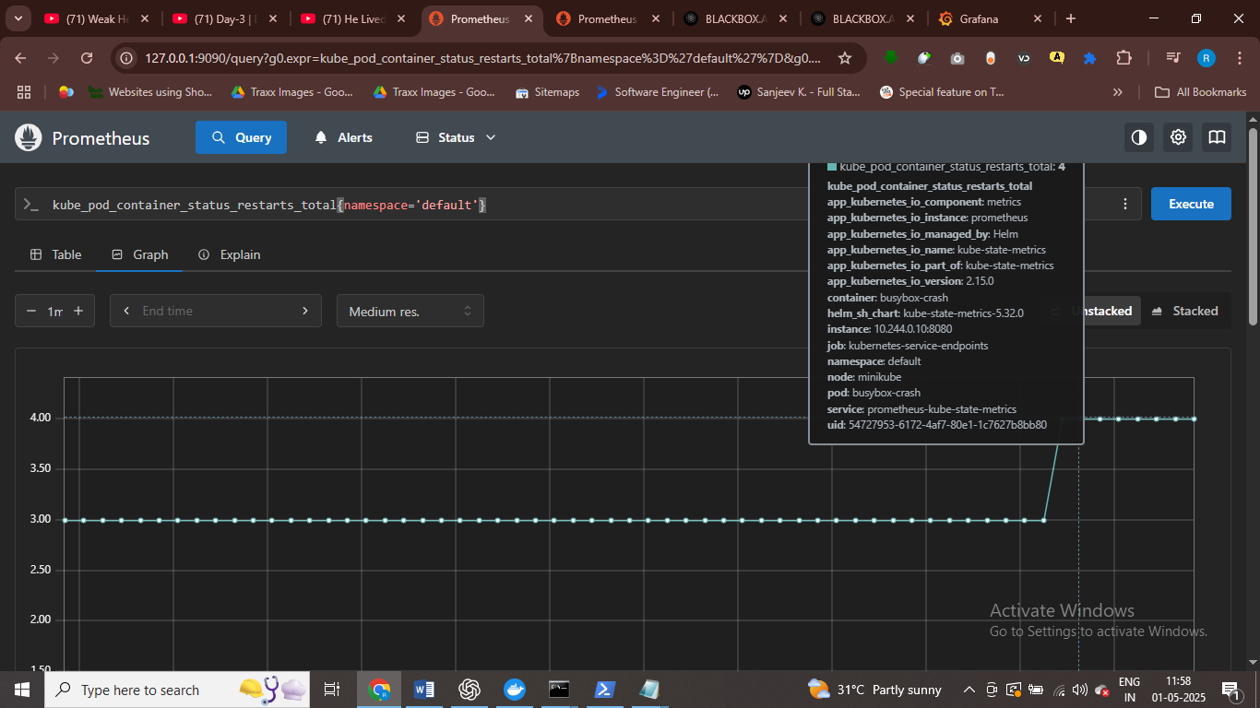

The graph is showing that pod crashed twice , one crash here

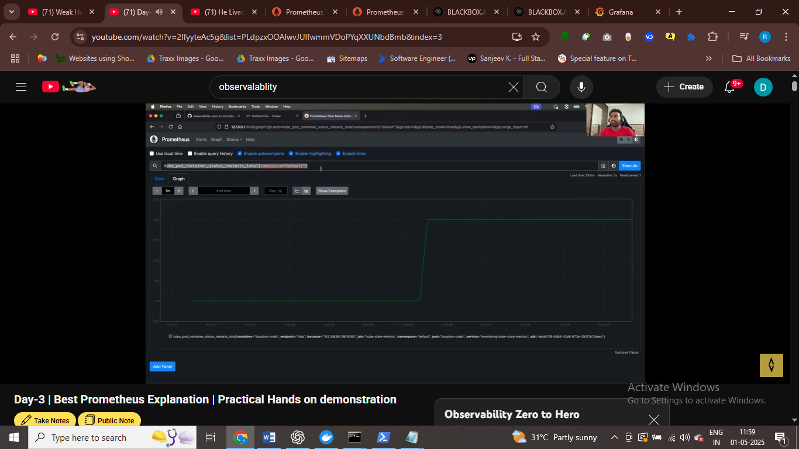

# we get dashboard in which we can now that pod is crashed again

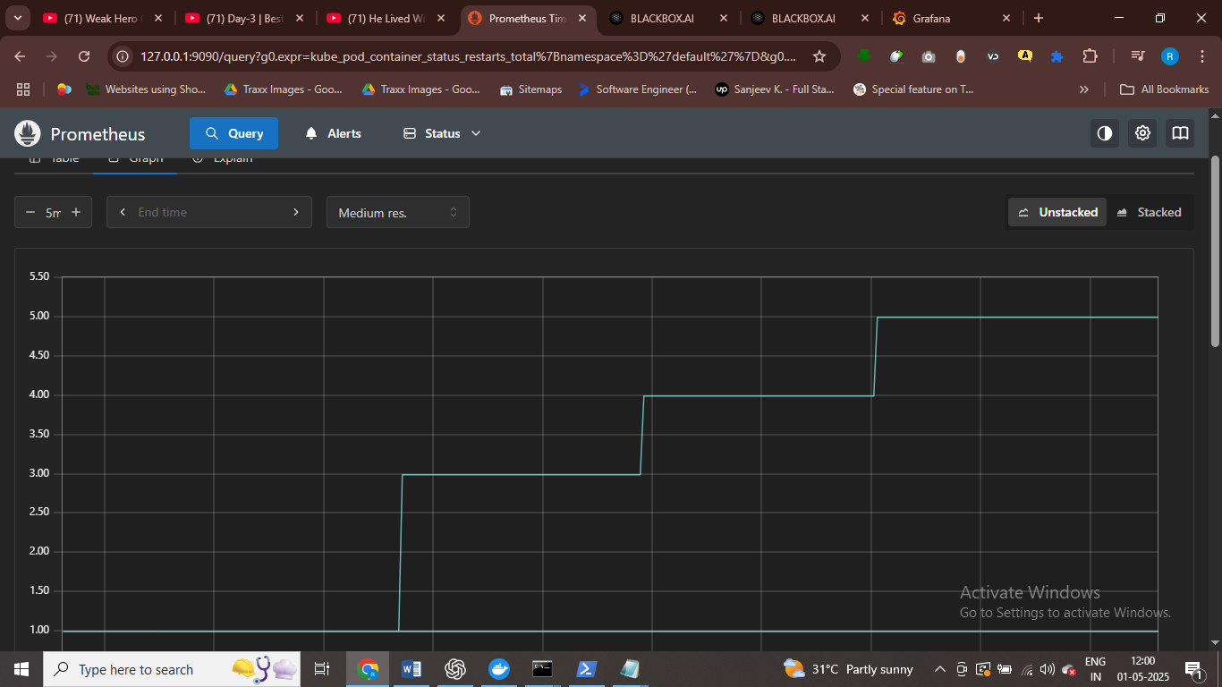

In 5 min pod crashed two times

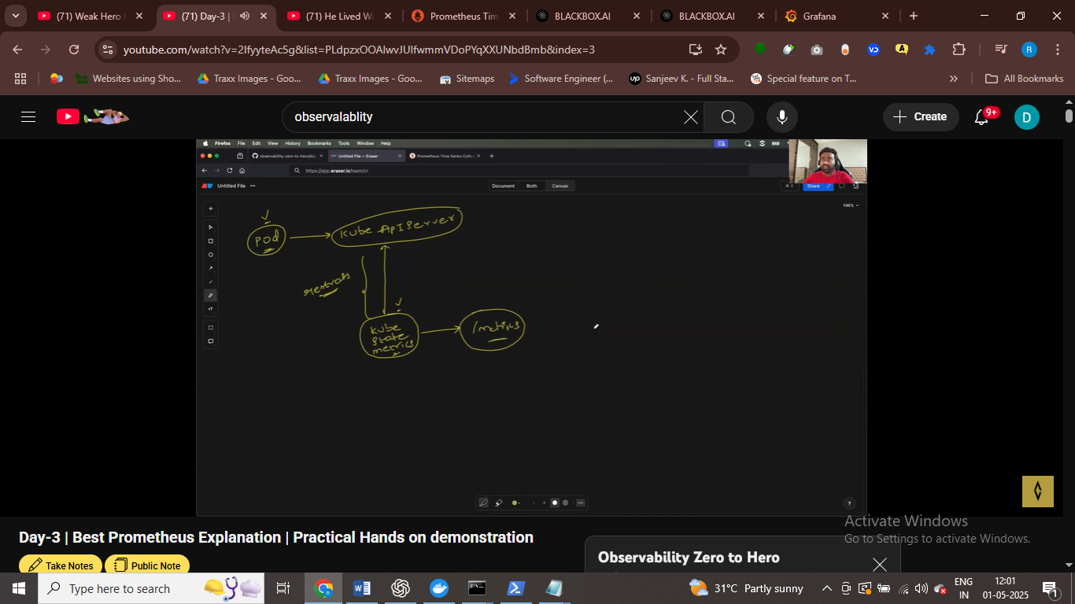

# kube state metrics continusly interct with api server and now that some pod is created

# pod is created and it see with kube – api server

Kube state metrics geeting infor from kube – apir server

Promeothous continusly watching state metrics at /metrics end points and as a user when firing promsql queries we get the info

Tehere sare 1ks of metrics

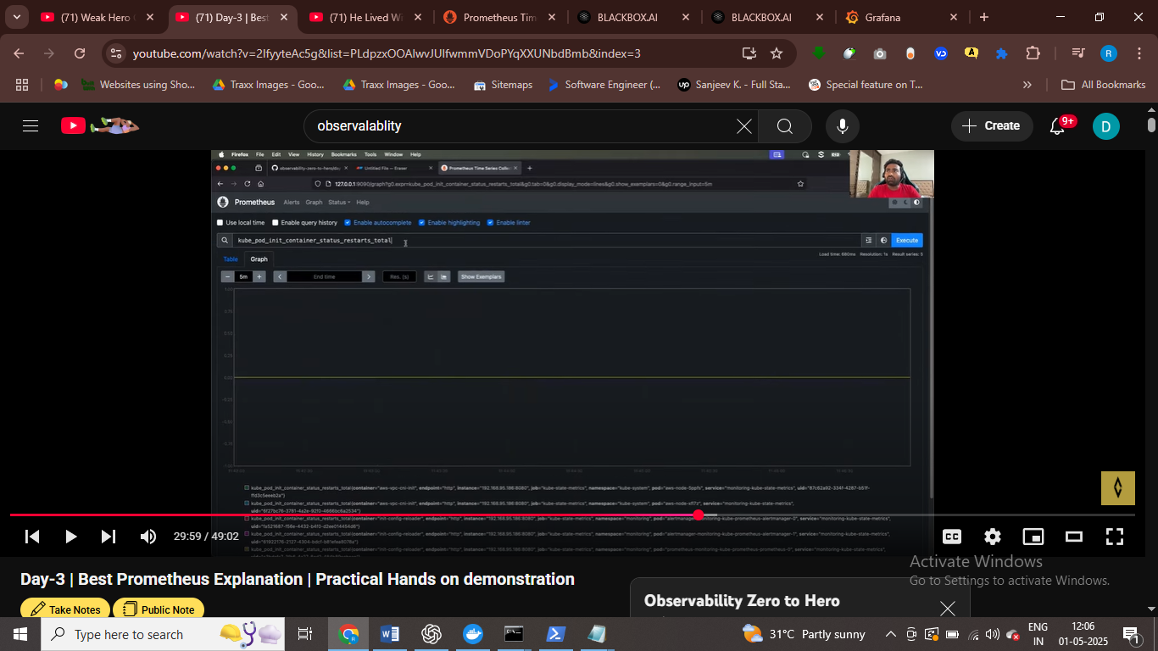

The cmd will return the metrics related to init container

Pod crashed metrics we can show easily

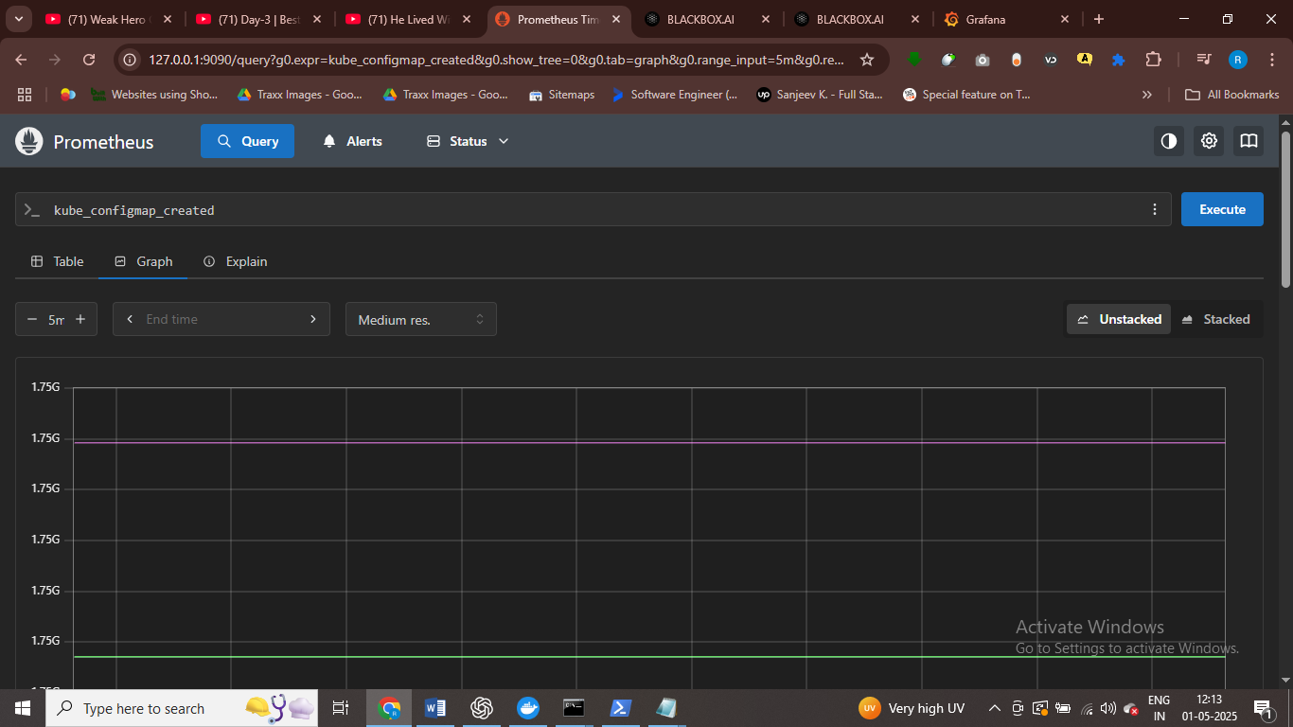

Show metrics when config map is created

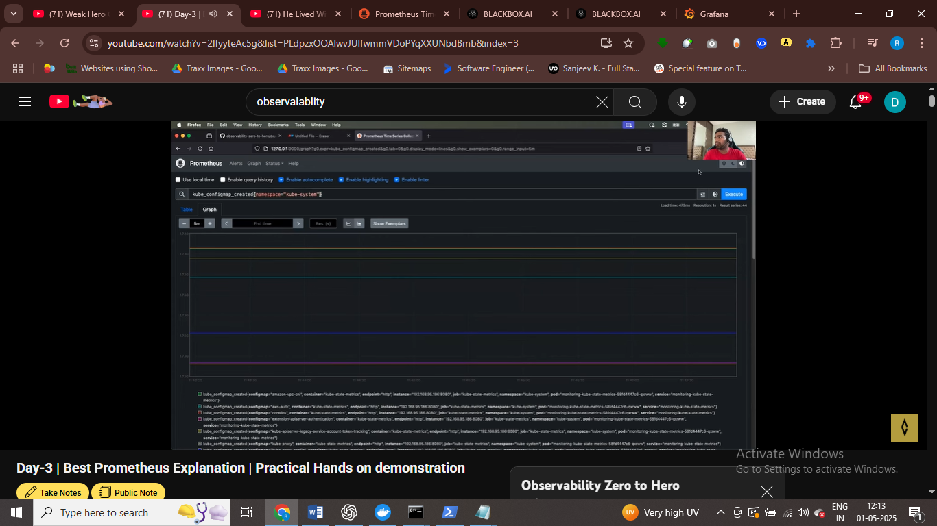

Metrics like pod crash

Metrics like pod has secret

How many secrets are in kubetens cluset

Cpu metmory disk untillization , http request and all how many

Thse are common metrics we have to discover

Through promethous we can sedn alrets also

Scraping metrics

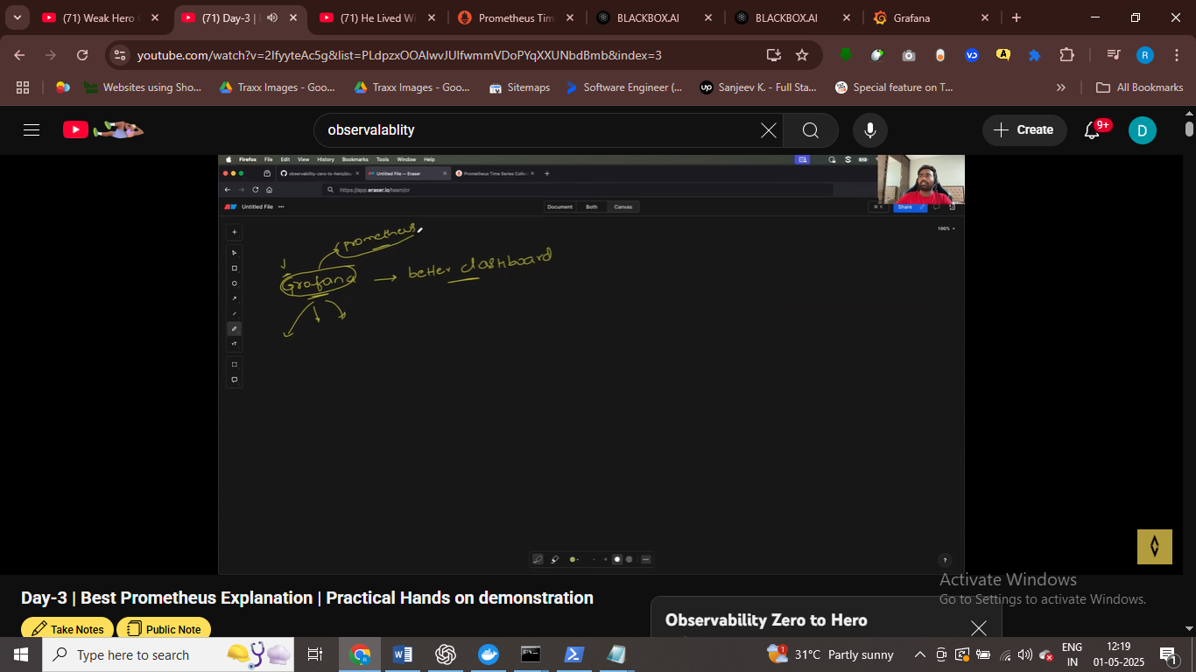

Grafana better vistulazation tool = not monitoring tool

Grafana authentication and authorization

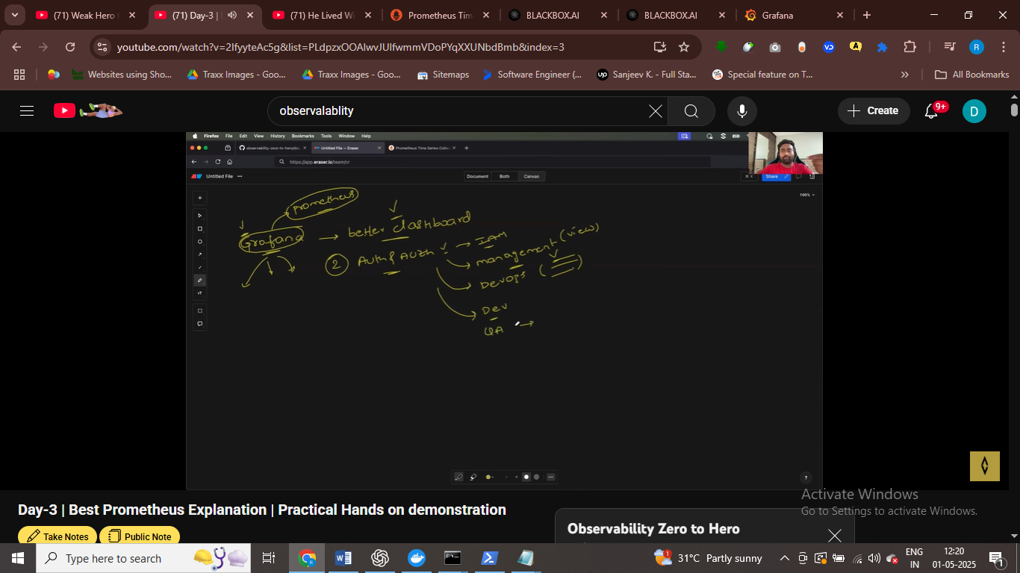

Only my manager see dashboard

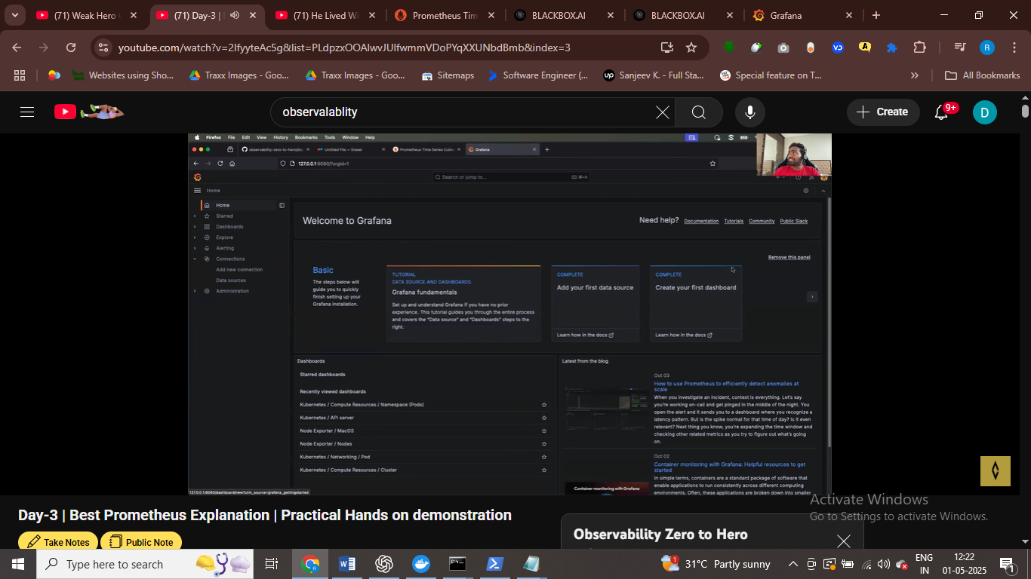

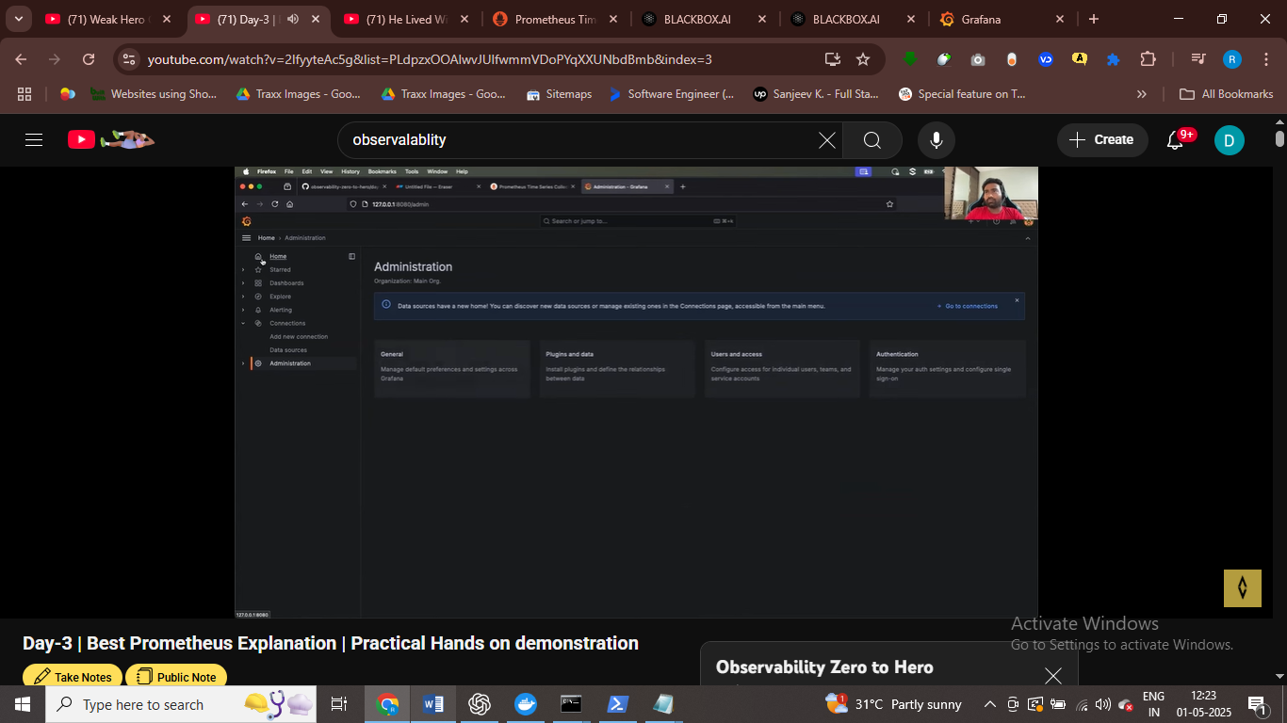

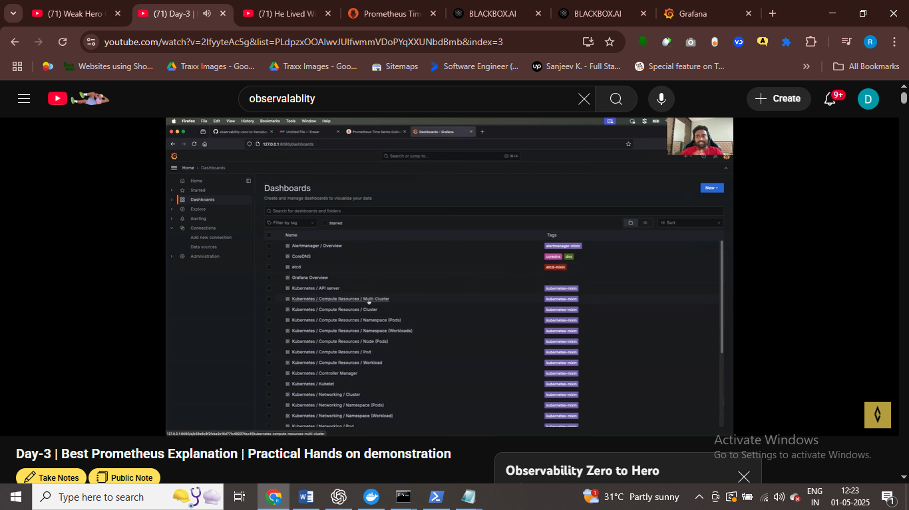

These are visualization dabshoard

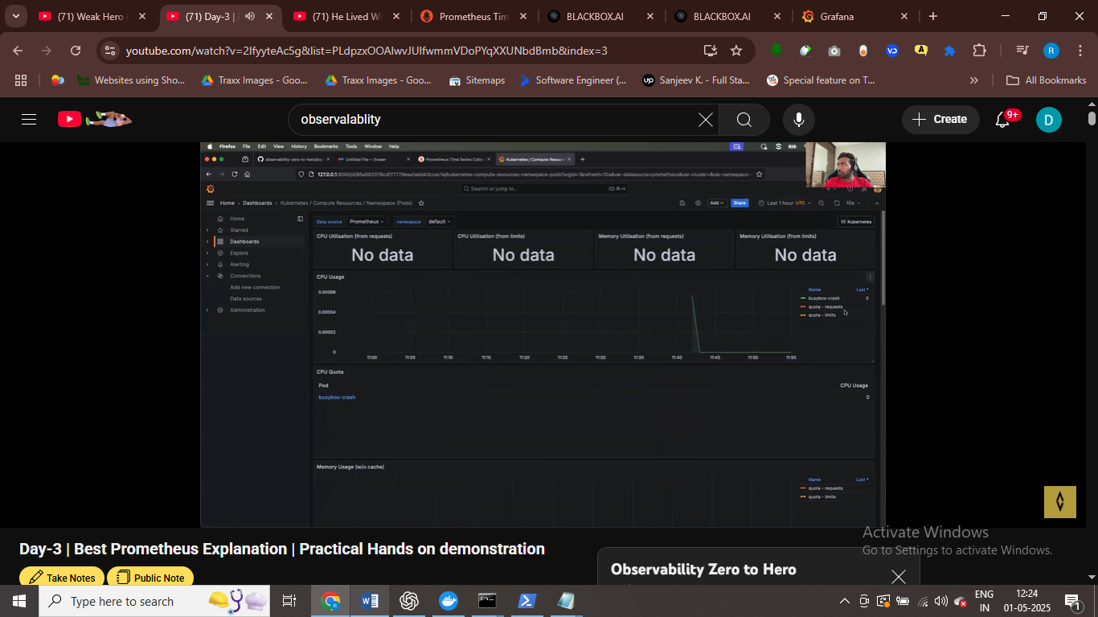

Showing pod info and it occupying 0.00006 info

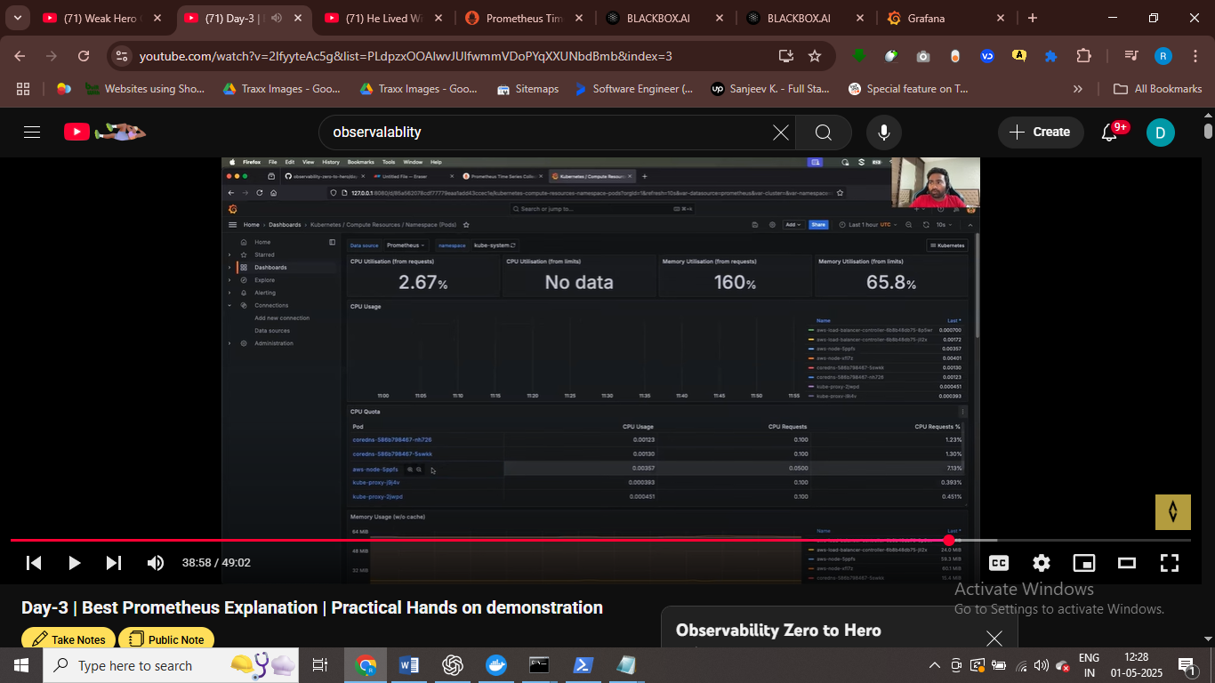

# inside diff namespace we are checking pod , that Is running

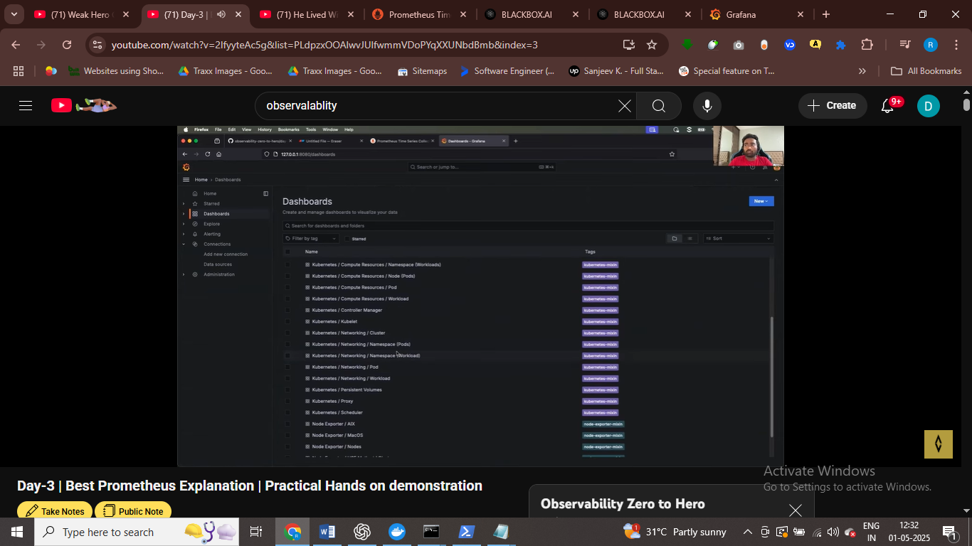

These are default dashboard for that grafana provides

Grafaana alrady indeity promethous data source so we can use it directly

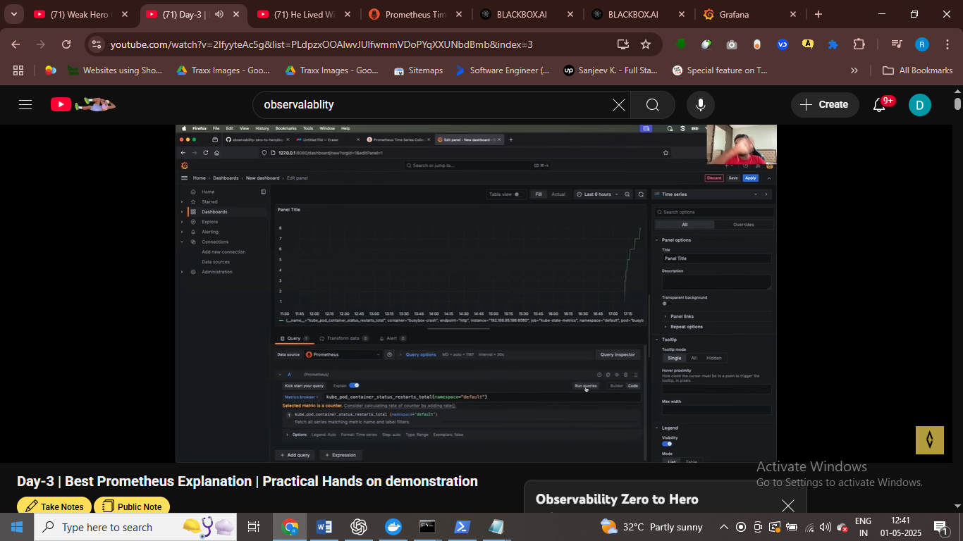

Collect metrics about pod init container

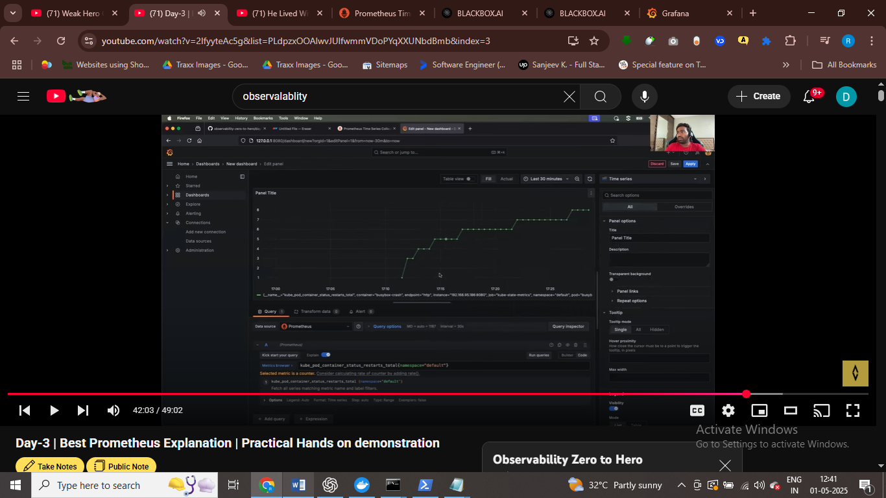the graph show crash loop back pod status

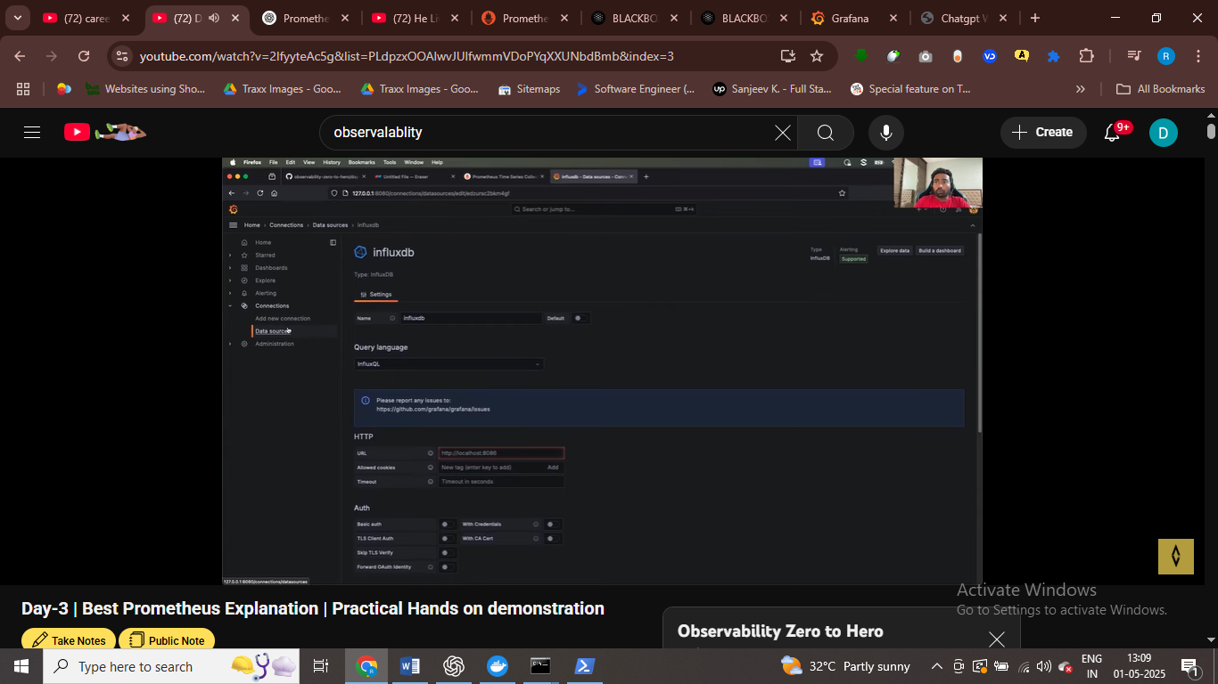

We can add new data soruce as well to

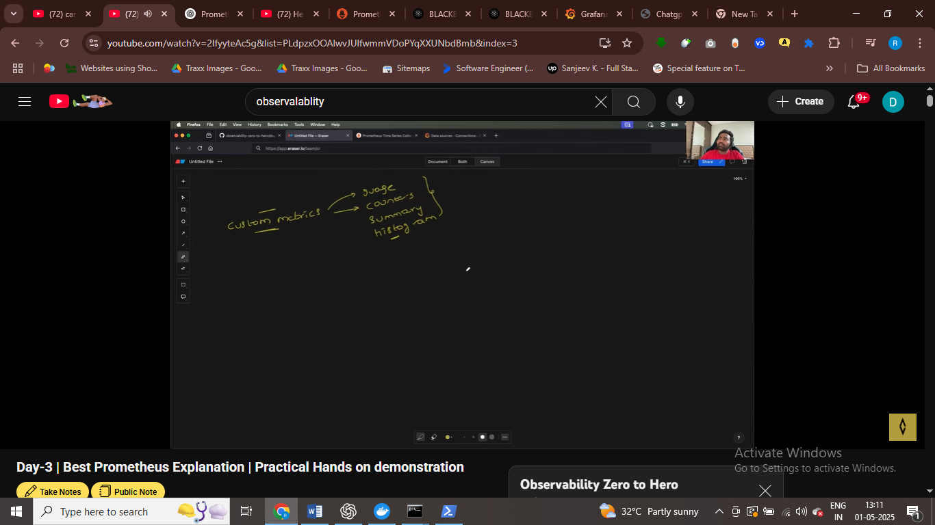

WE CAN have 100 hundered of metrics

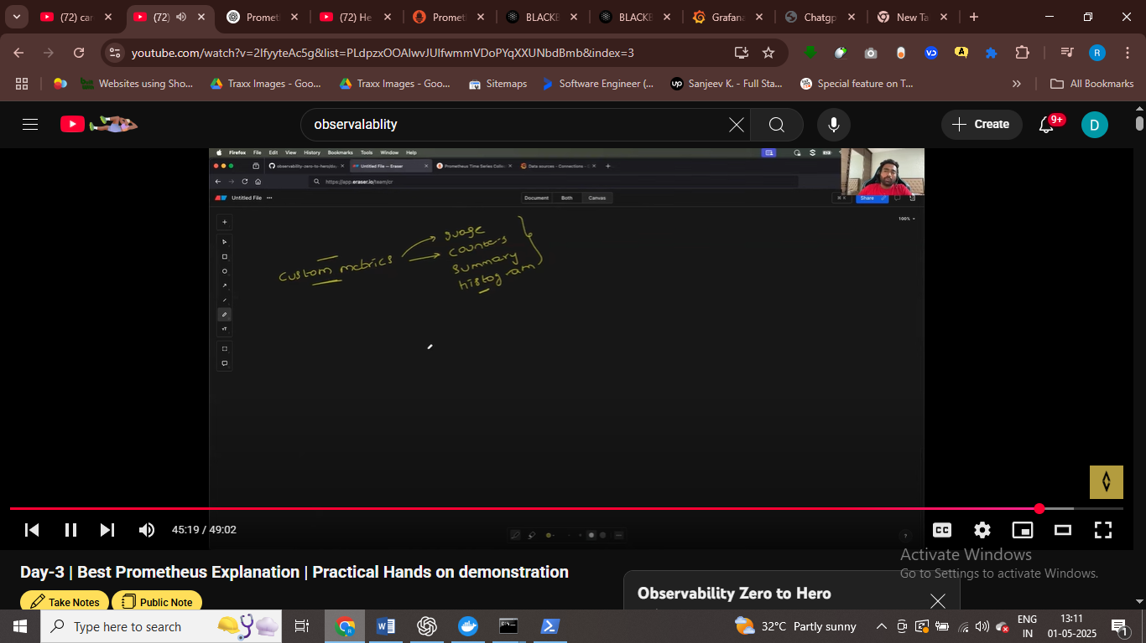

SERVICE MONITOR

* Actually it generally watches for the service that is giving metrics
* We can use service monitor for this
* We write queries for the metrics we have
* WE SOTRE all our metrics in time series db

DAY 4

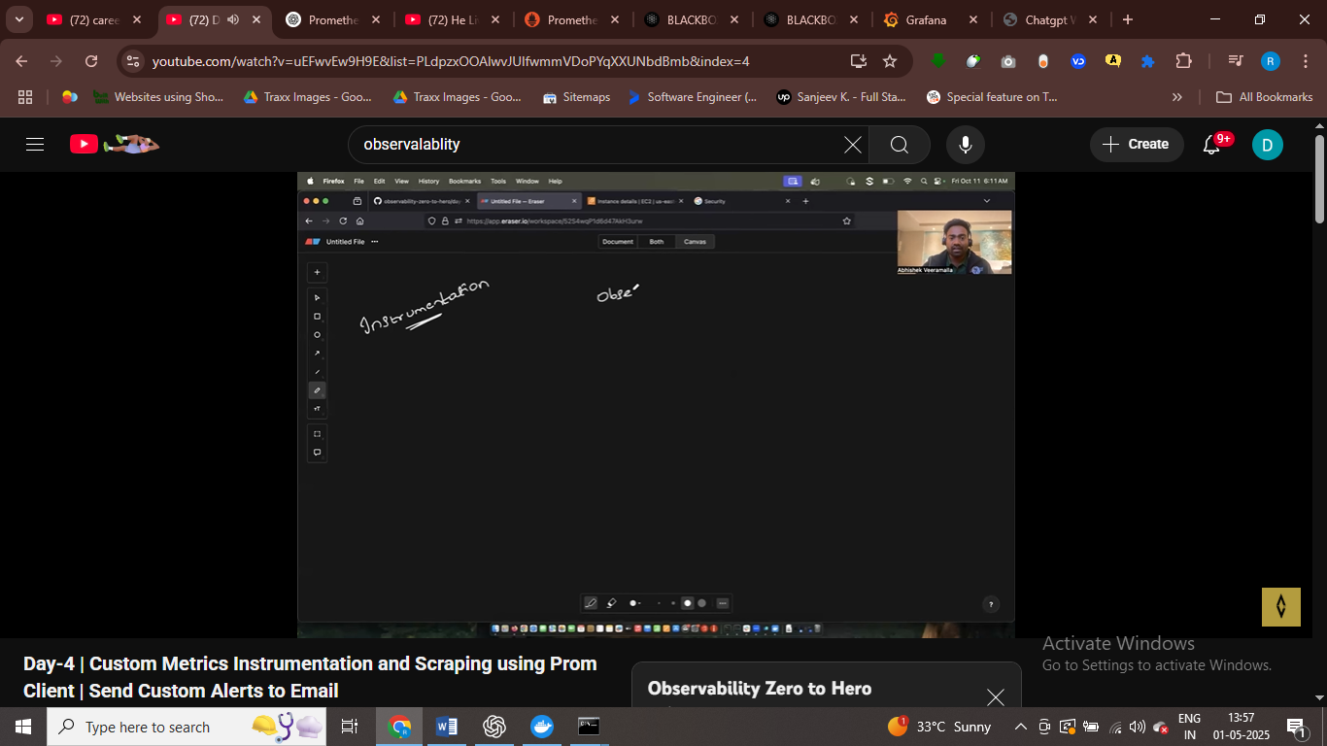

Prometnhous for motioring

Grafana for advance dashboard

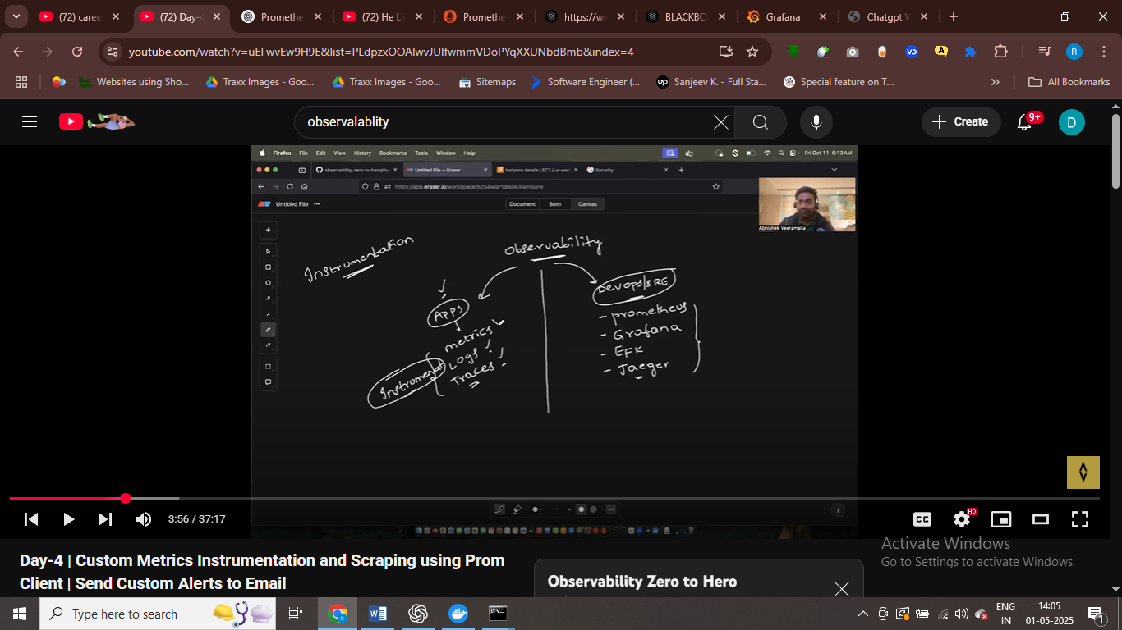

Writing the logs , metrics , traces in the appn , is knonw as instrument

Exporters are just pluigns they are just giving specific metrics

It just return metrics

For appn specific use insturemetns

Instrumetnation taken care by developers

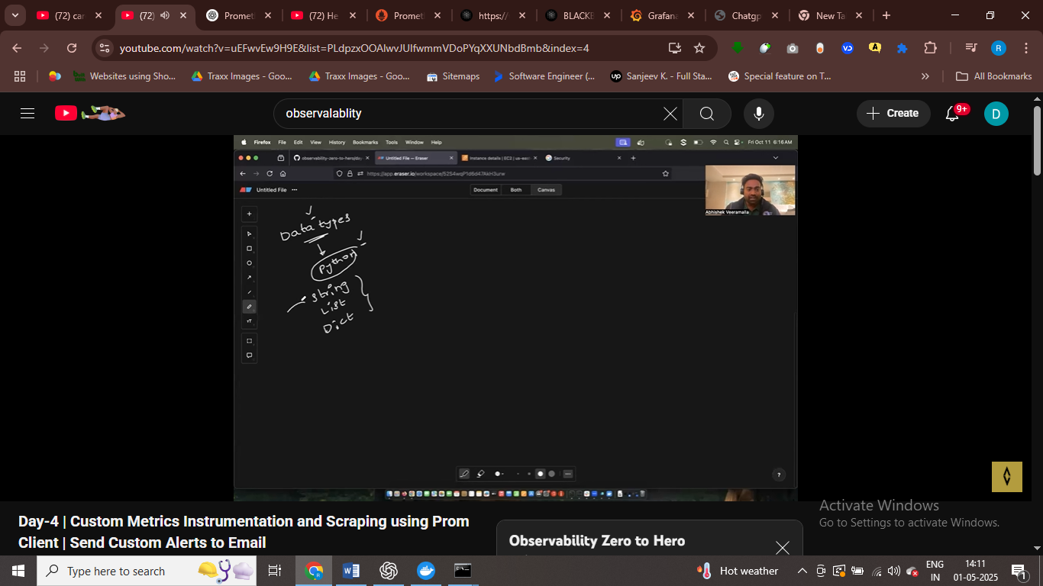

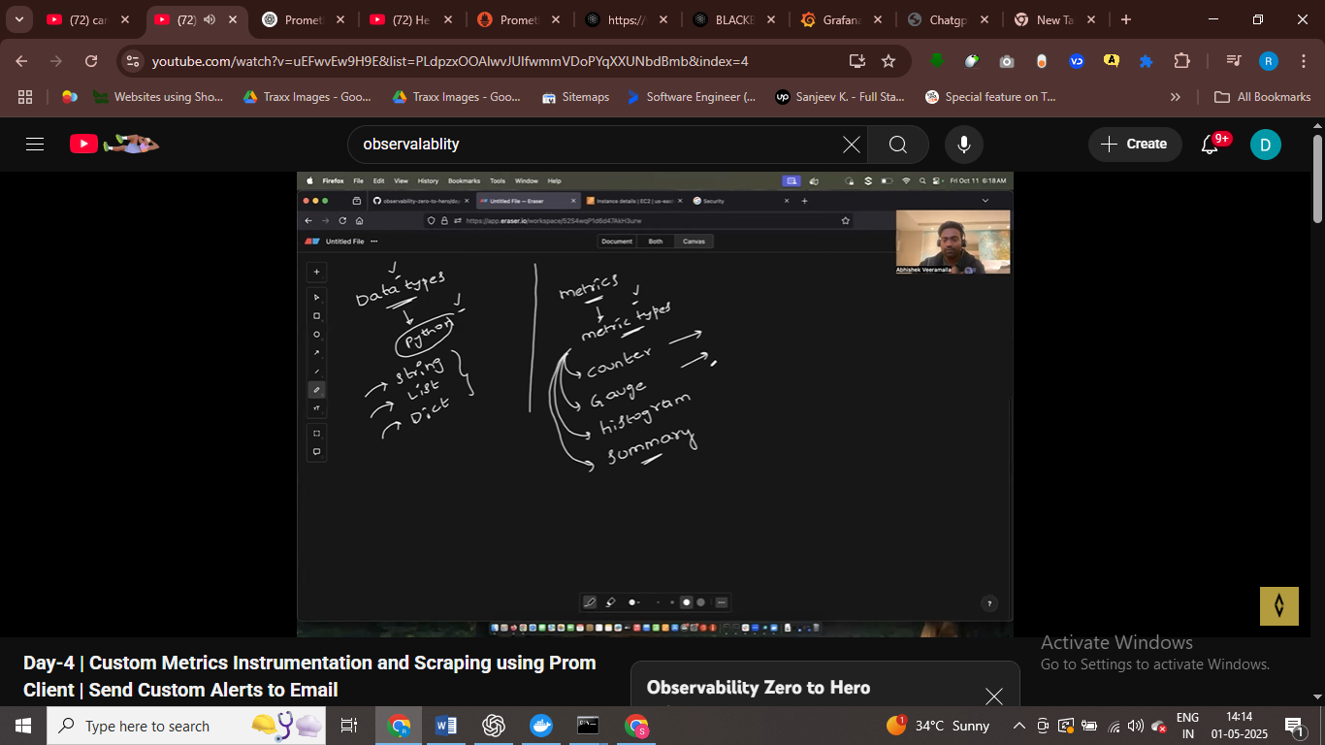

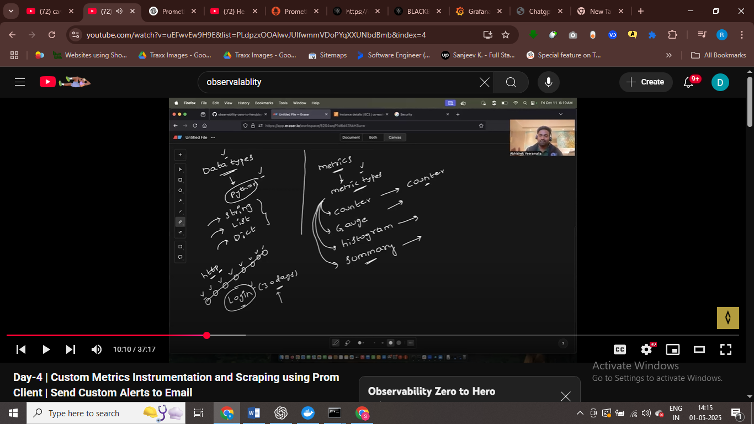

The metics that keep inscreaisng such as login – login keep increateing – then counter matrics

Increatemiting no that is counter

Gauga – inc or dec no

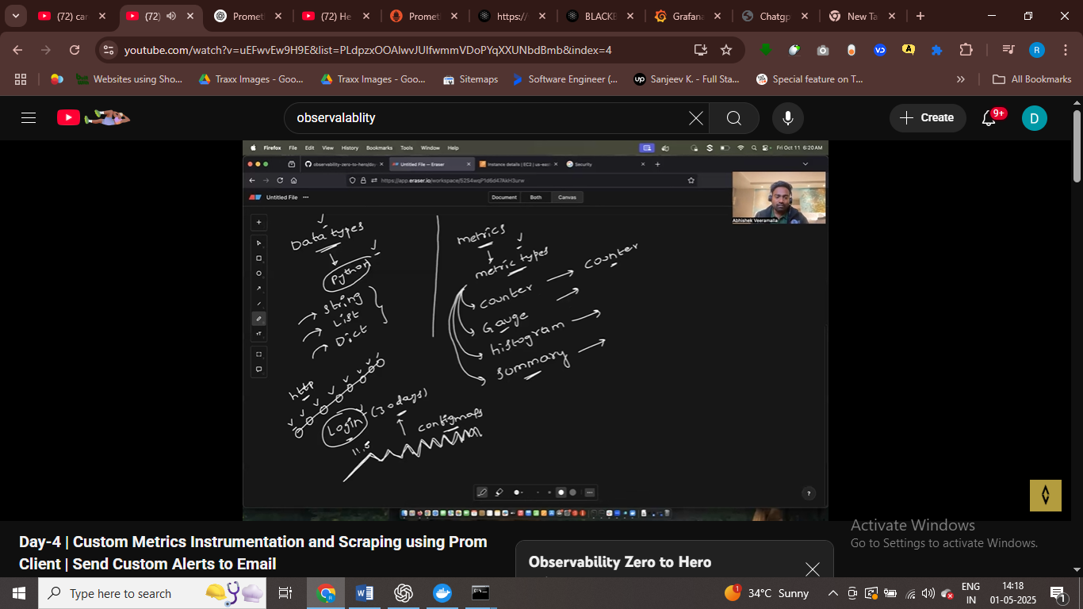

Configmap ex of gauga

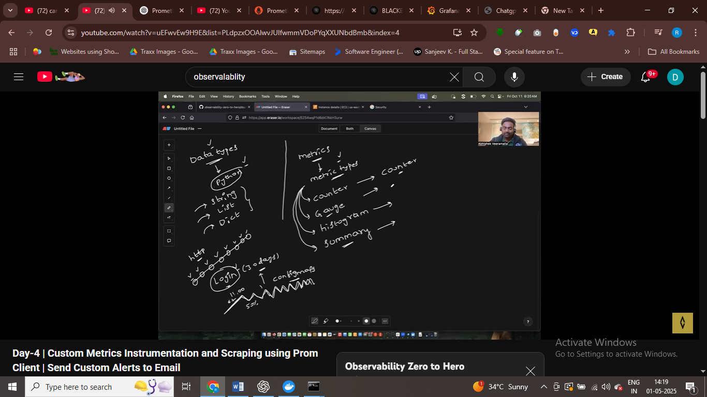

http latency

how many time cpu less than 50 percent = use histogram metrics for it

service discrover

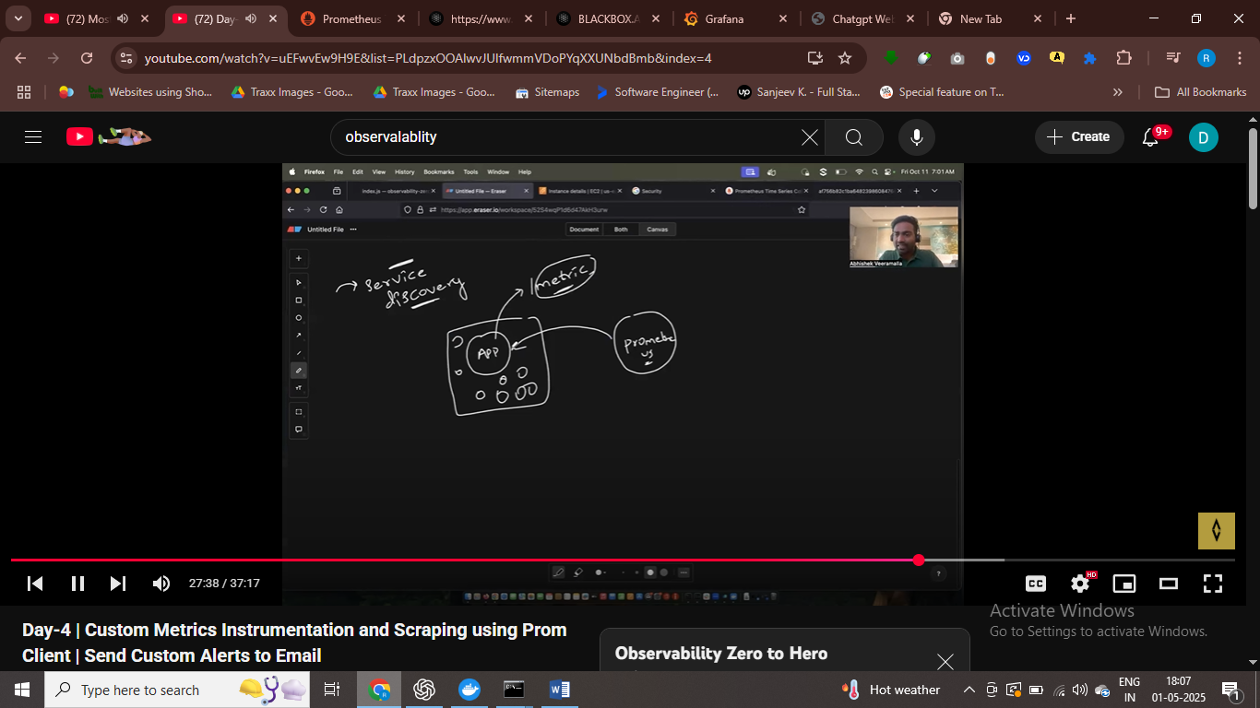

To identiy the appn , we use serice discovery for this , now to

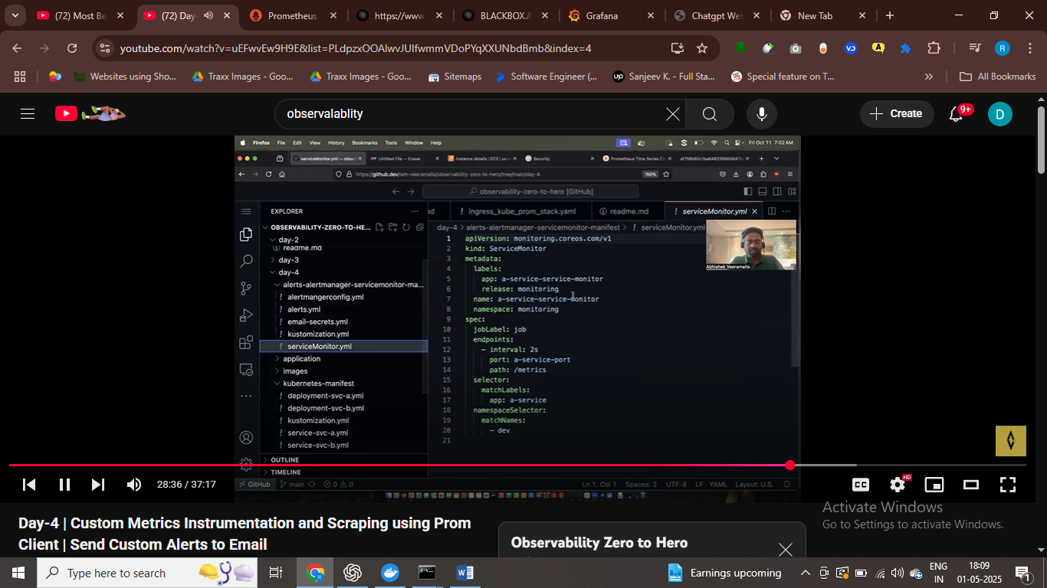

In the dev namespace match the pod with a-service and fetch the metrics from the /metrics end points

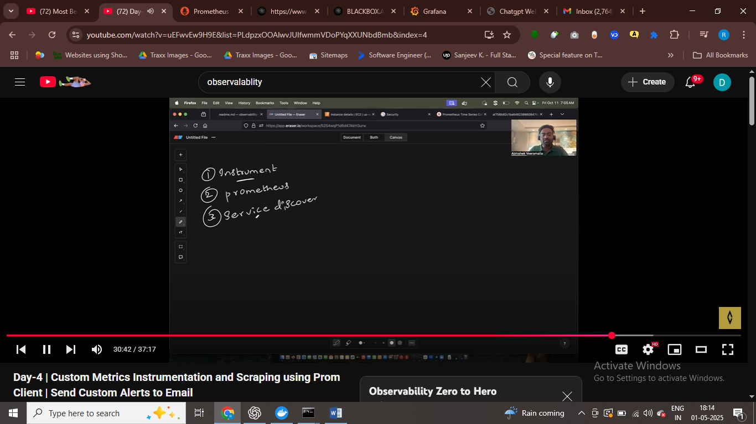

First one instrument the metrics

Second one set promethous

Then service discrovey

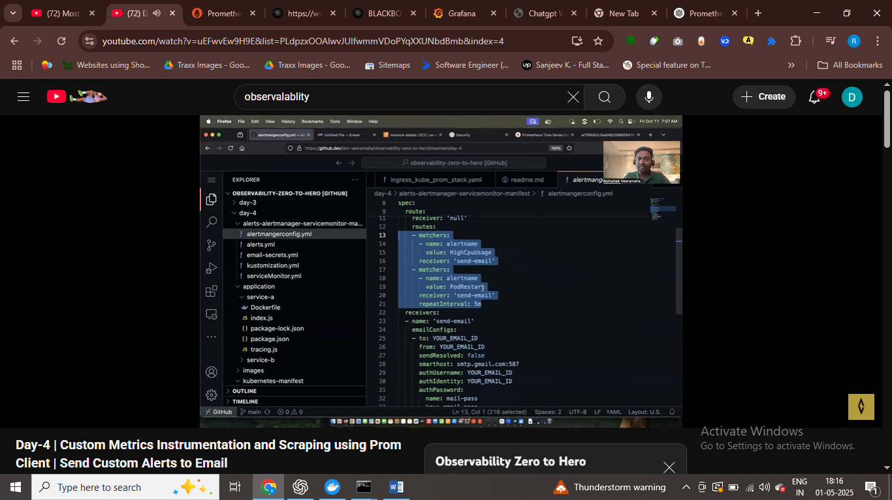

Alert fire using this file , for cpu usage alert fire

Alert manager.yaml for custom alrerts we can fire it

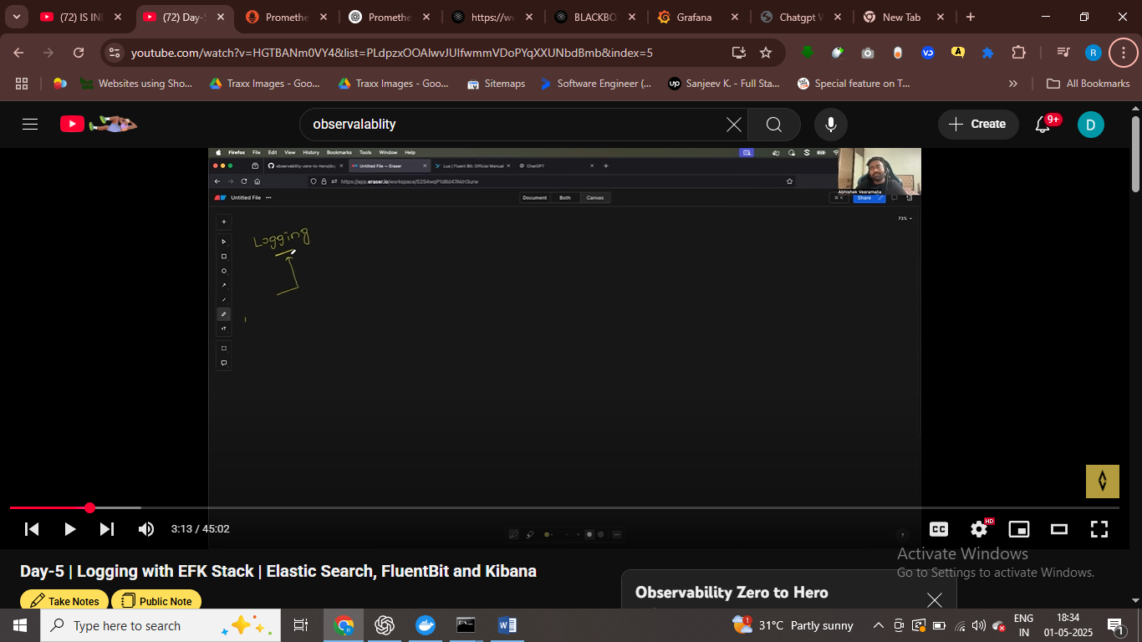

Day 5 Logging

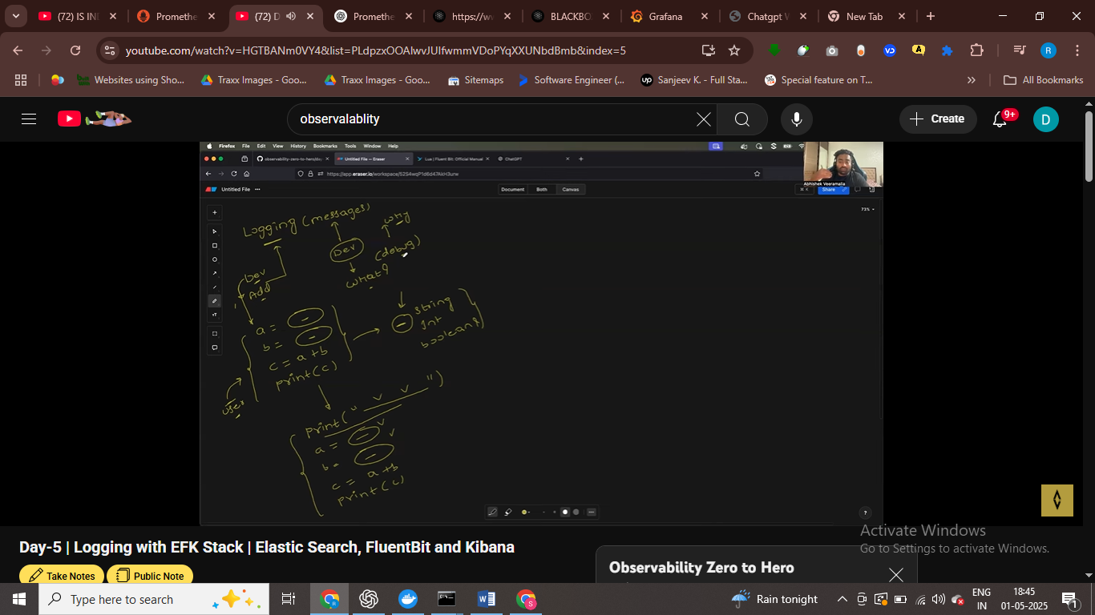

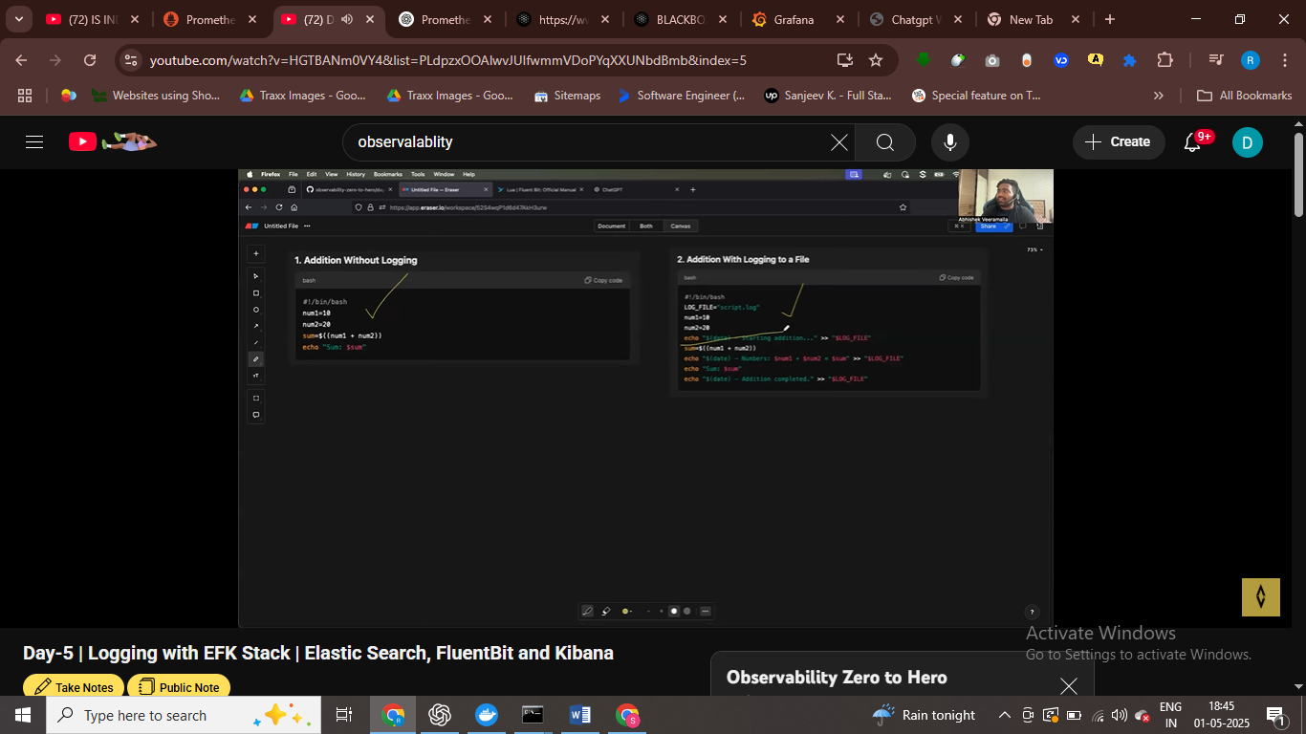

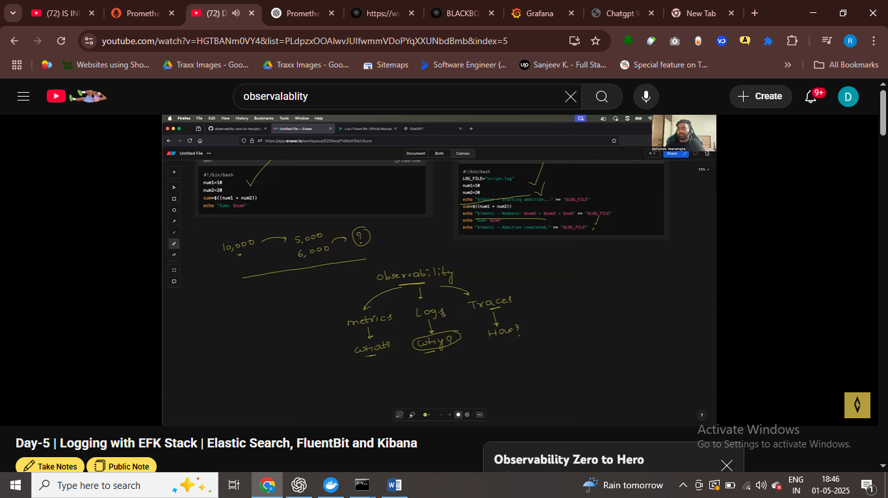

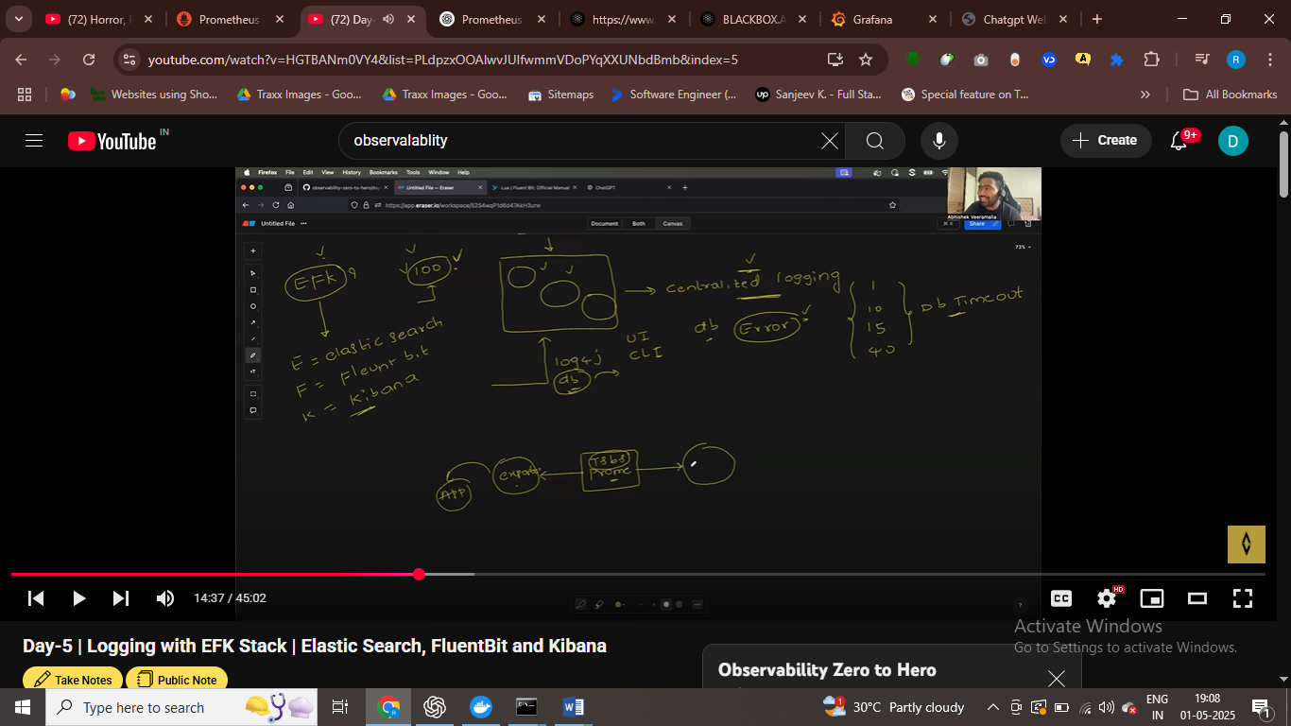

Proemtn store all metrics in time series db and it use exporter to retirve metrics from the appn

These exporter take metrics form the app and then we store in time-series db

There is graphical reposerntaion and dashboard in grafana

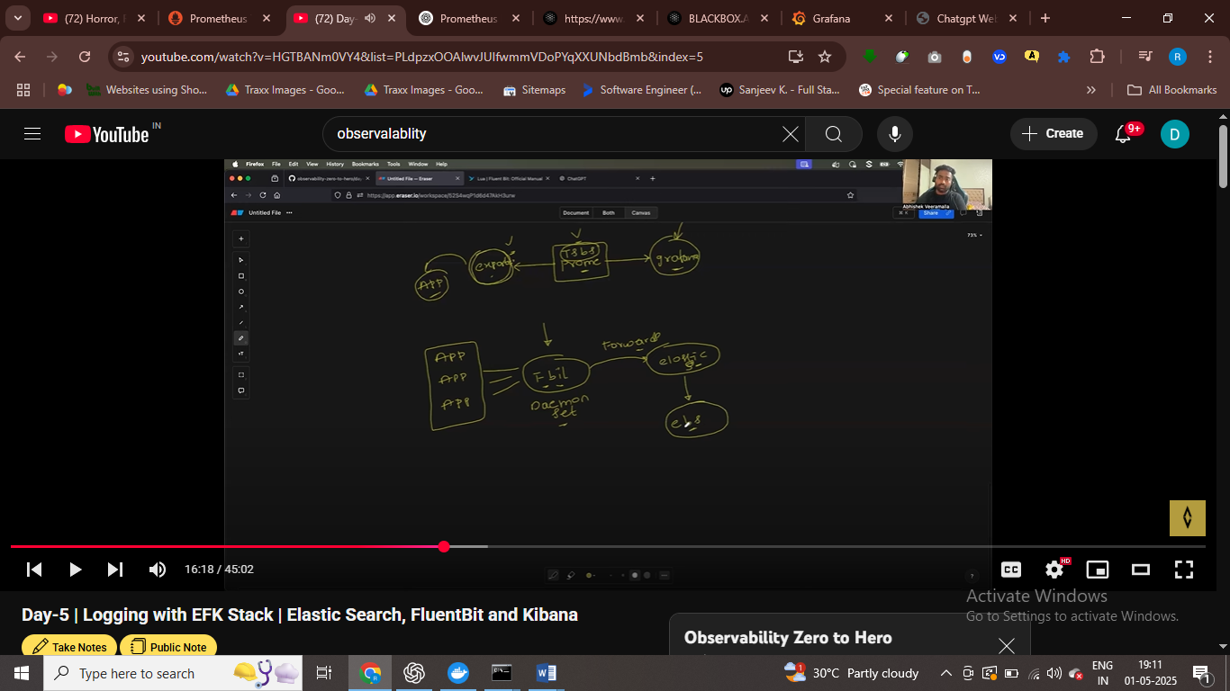

In the elk stack we have , we have fluent bit , that is daemon set we have , and it like exporter we have that retrieve metrics and we store our logs in elastic search , and we can attach elastic search to ebs volume = so that we can take backup of logs

And therir is visualzaiton dashobaord such as kibana we have

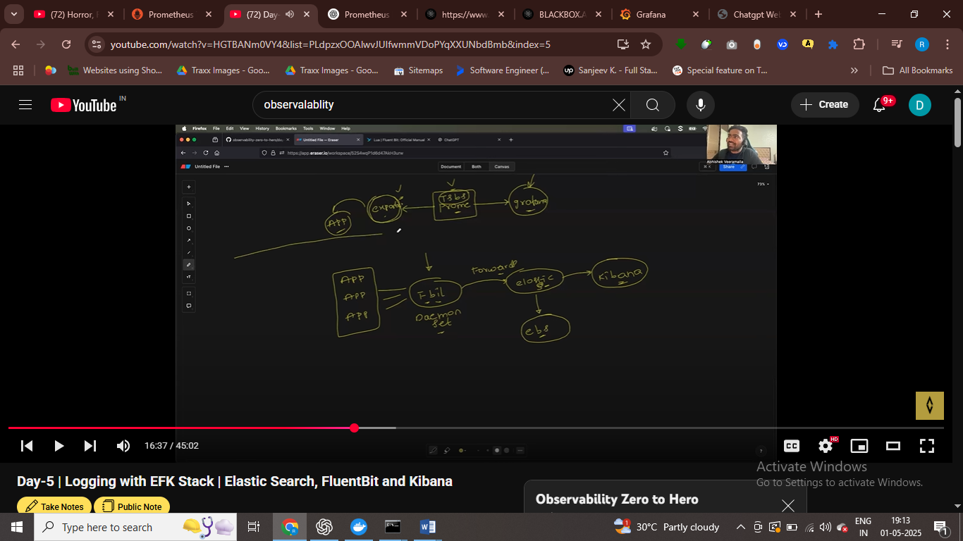

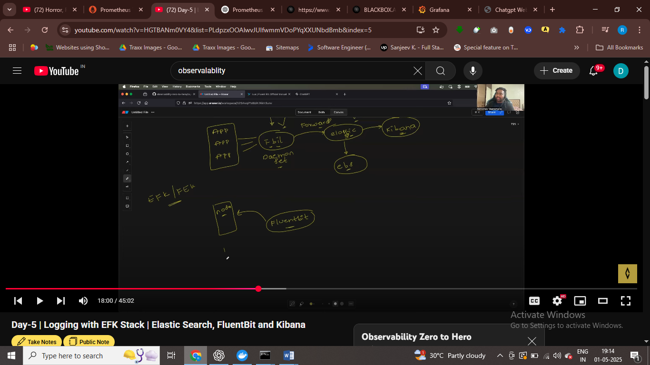

Flutent bit read logs from all the node from kuberntes cluster,

It is deployed on each node of kubernetes cluter

After this it forwared logs msg to elastic search – it’s have db in elastic search

Take backup of elastic search , using persistatnt volume

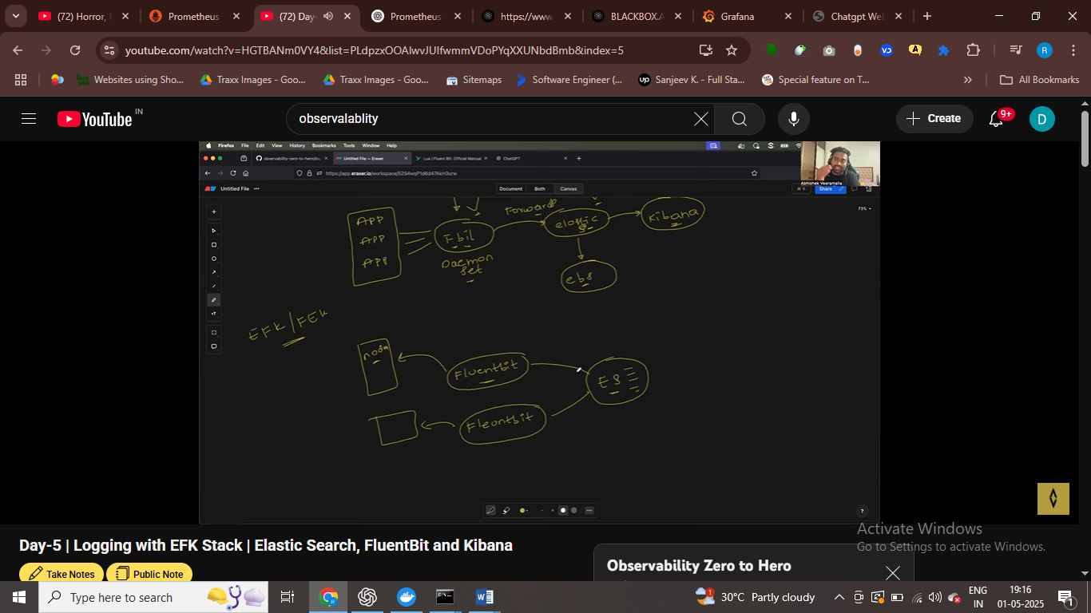

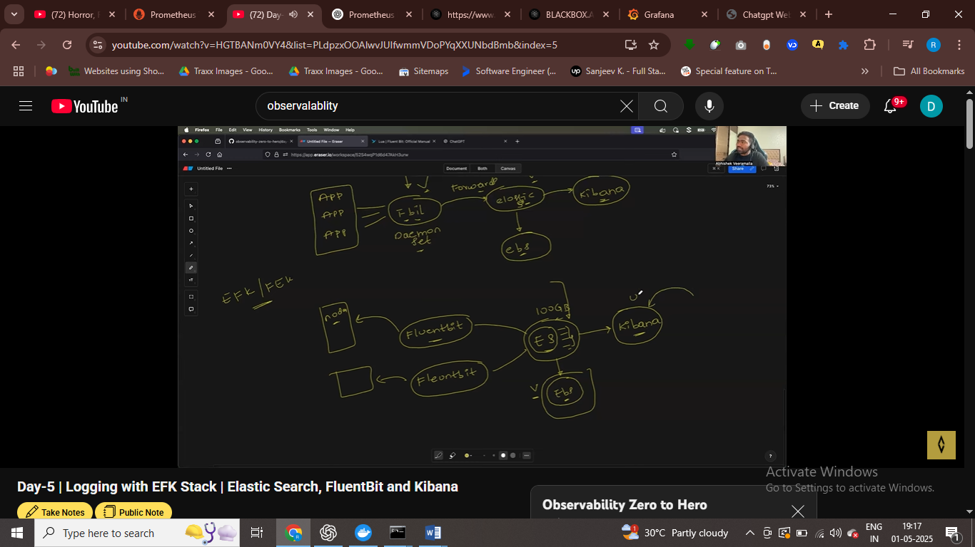

Kibana similar to grafana

EFK } ELK STAKC

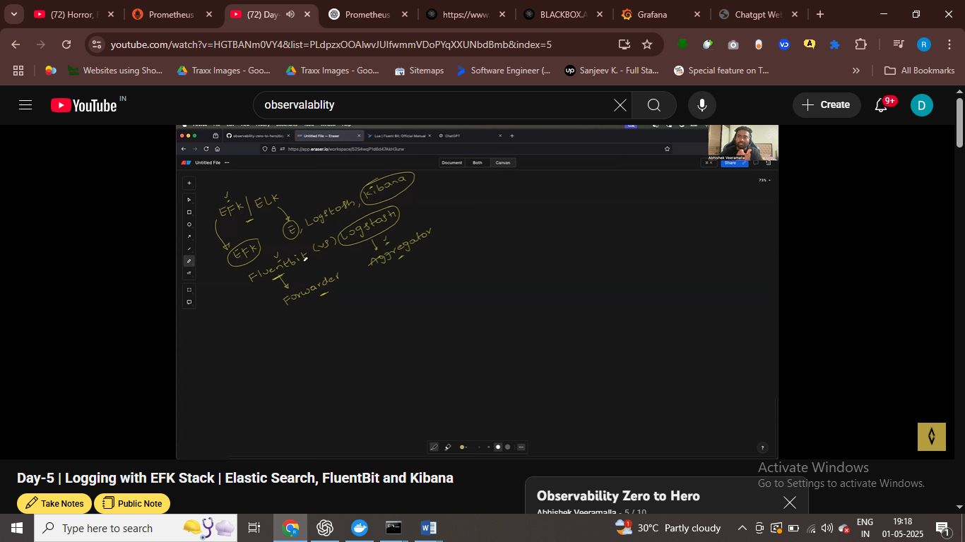

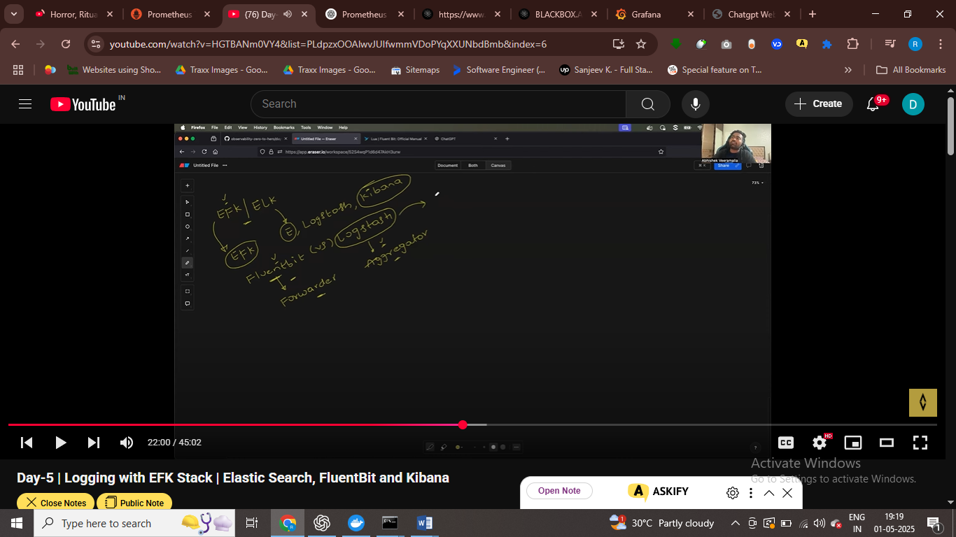

Using log stash we can do advance filtering , advance labelling , and then forwared logs to elastic seac

Use fluent bit light weight , basic ,

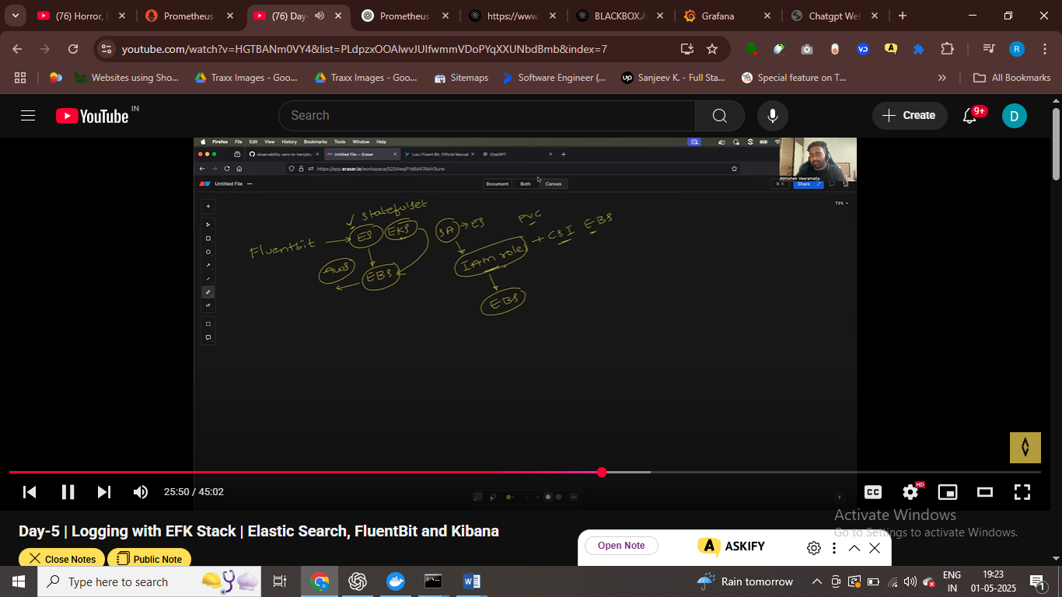

We can use iam role – with service account to connect to eks with ebs volume

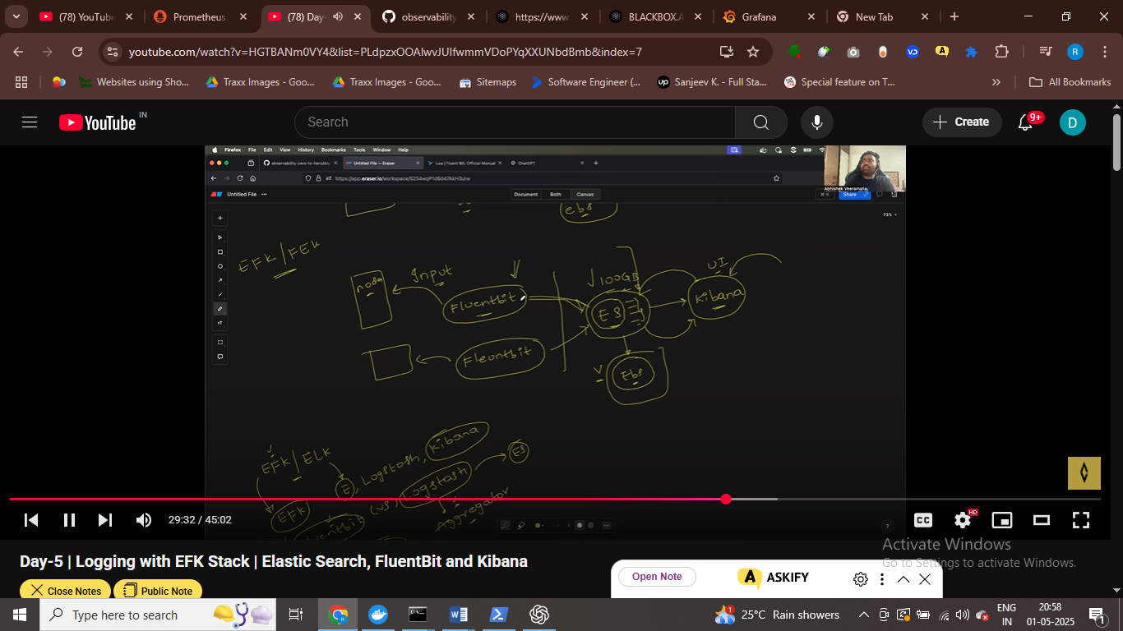

Fluent bit need authentication to sedn logs to elastic search

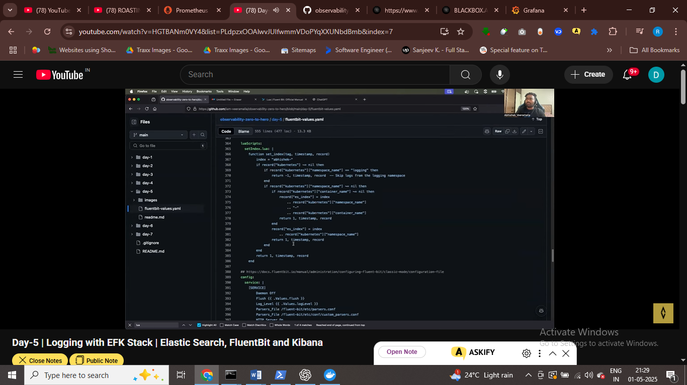

Insllaing kibanra and elastic

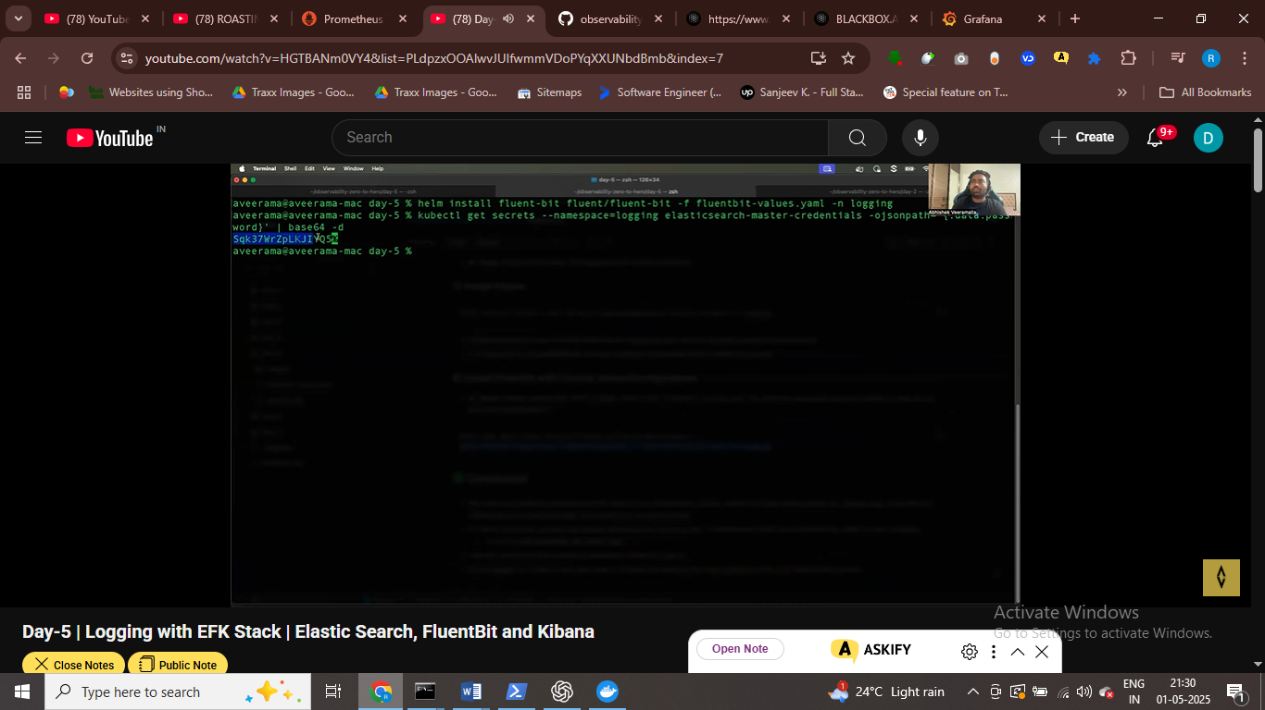

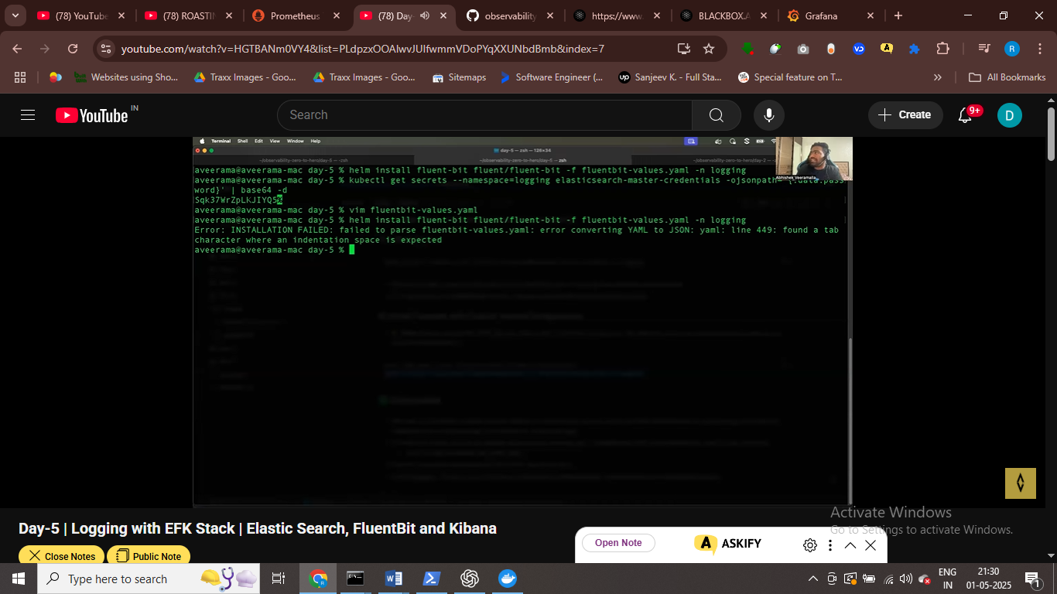

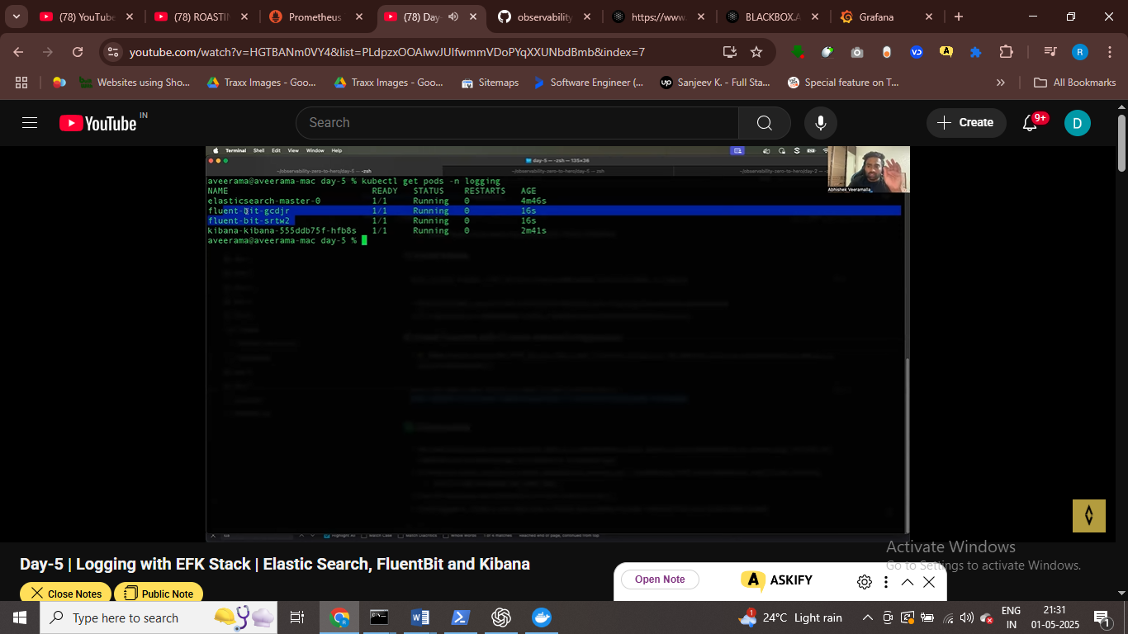

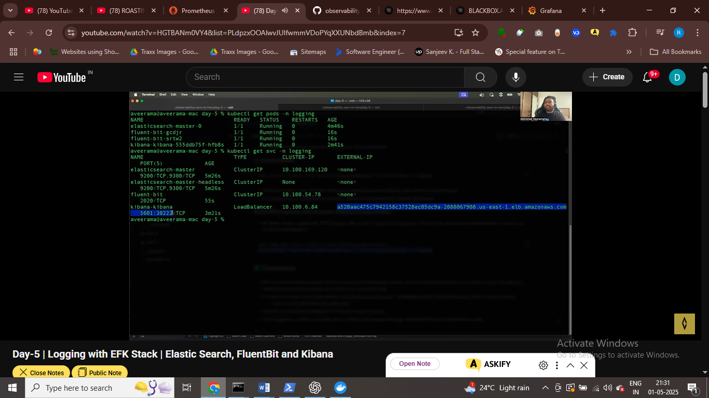

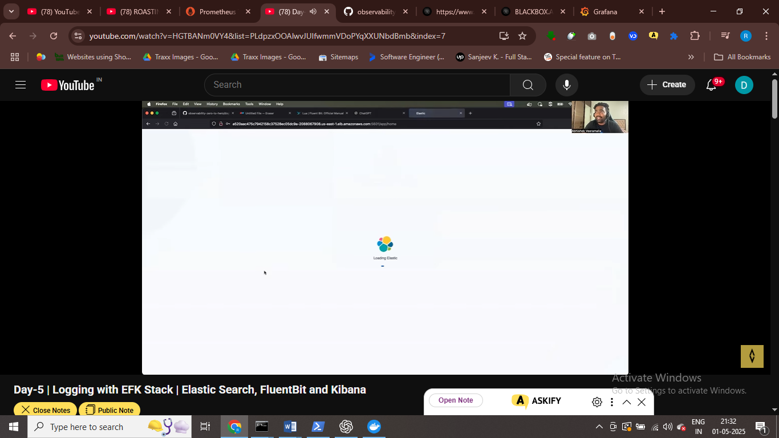

Kibana dashhobard acutoamcally connect to elastic

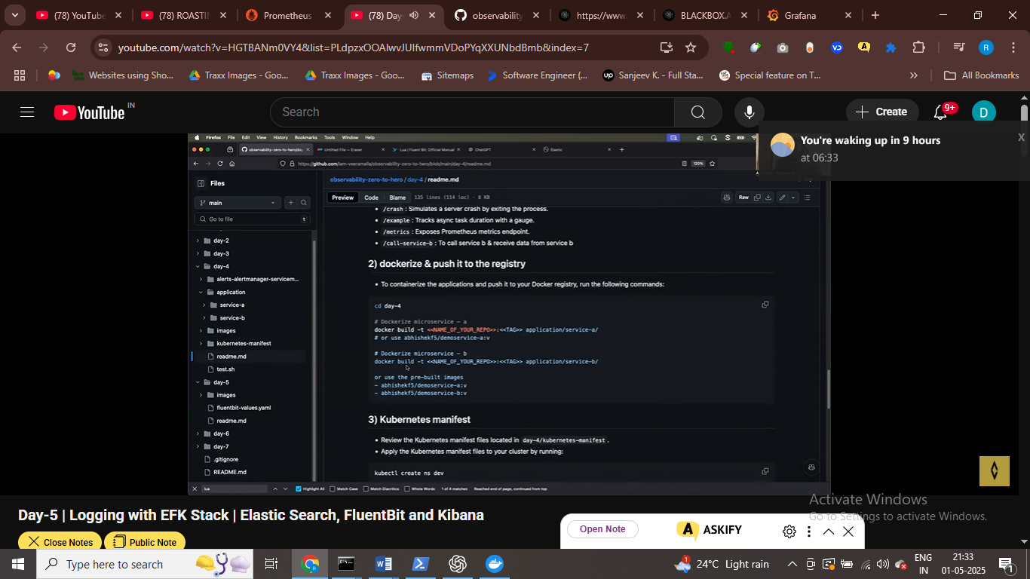

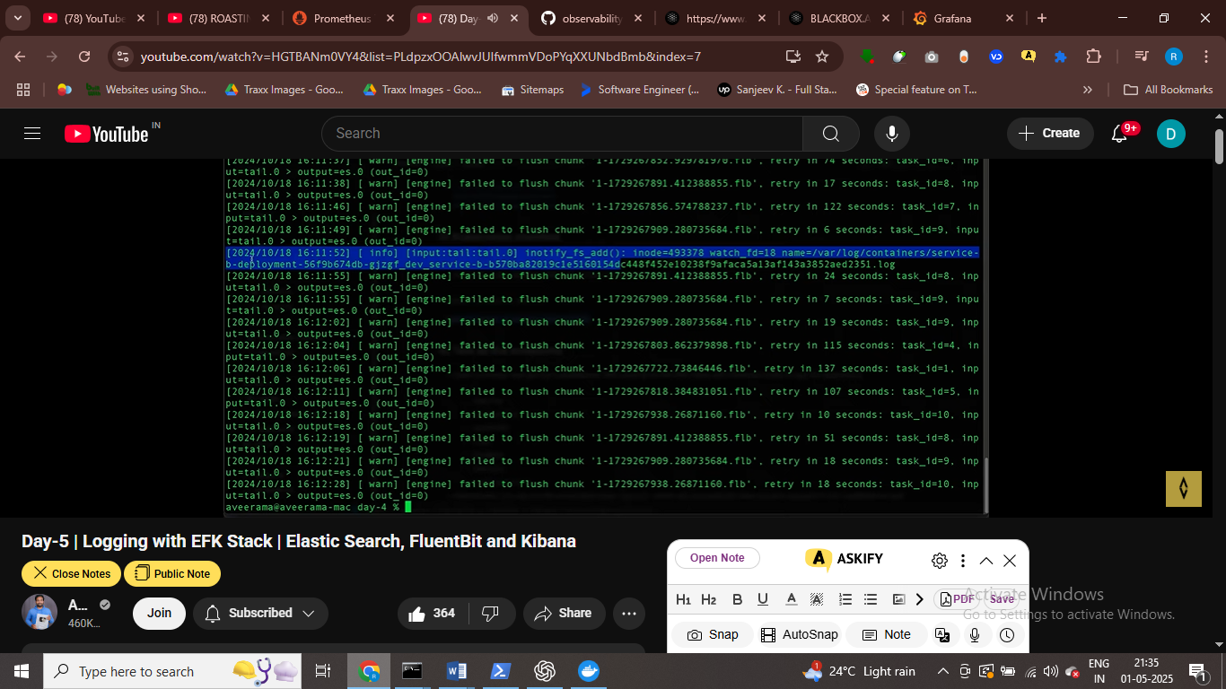

Flutnet bit logs after deploying appn

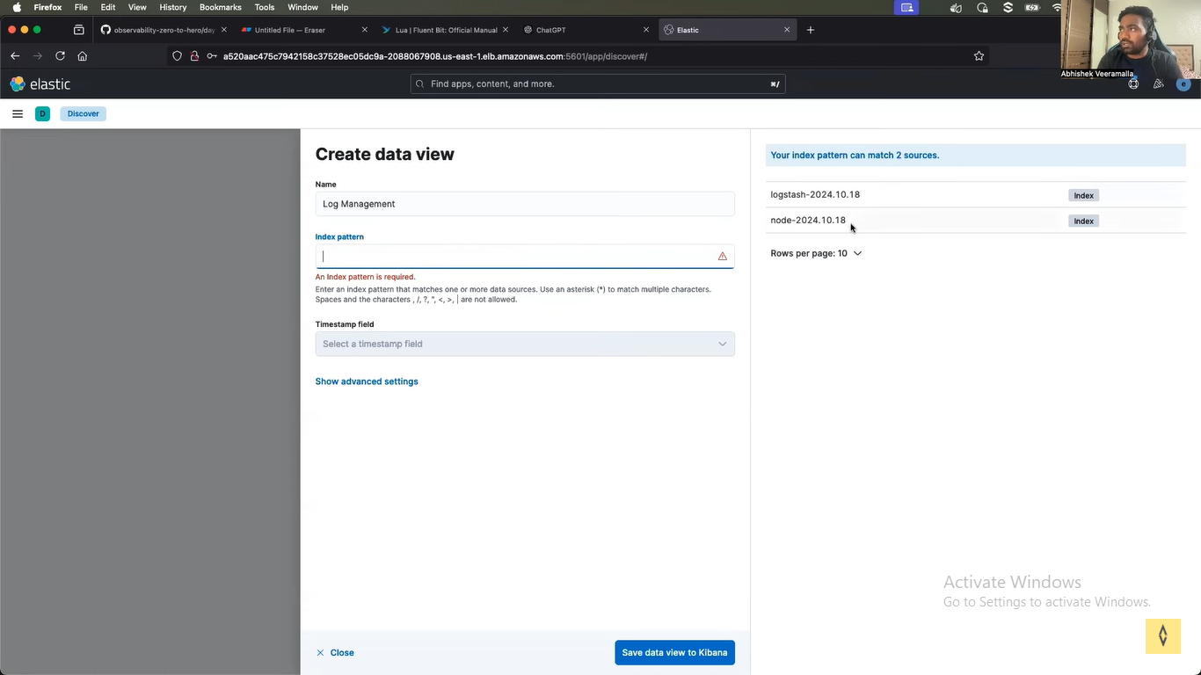

Crate data view in kibanaa

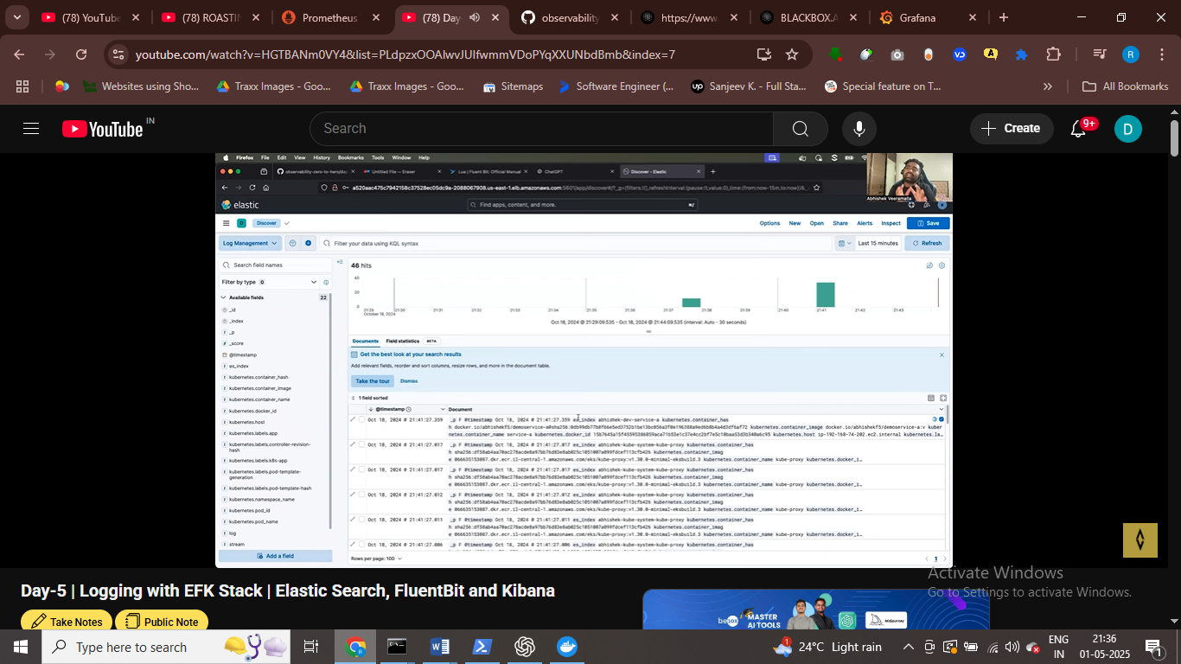

Kibana geeting this from elastic search , elastic search geeting this from

We can use kibanaa query lang to filter out some logs

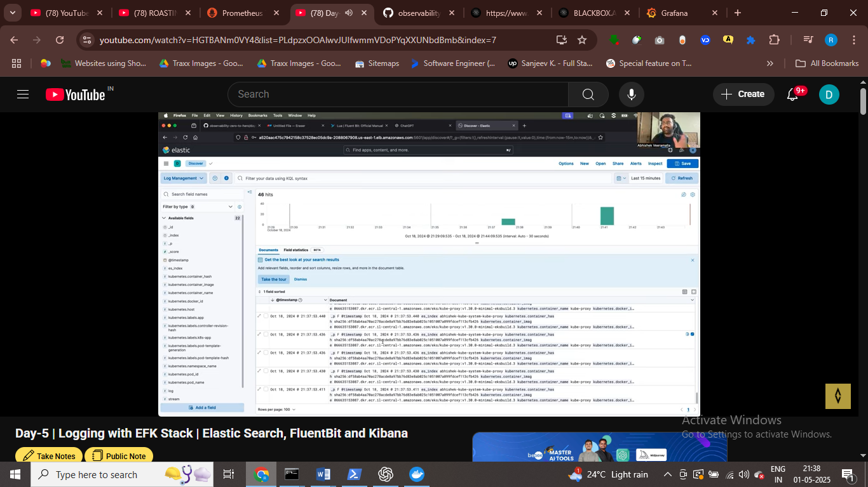

Fluetnt bit is vendor netural – adv of

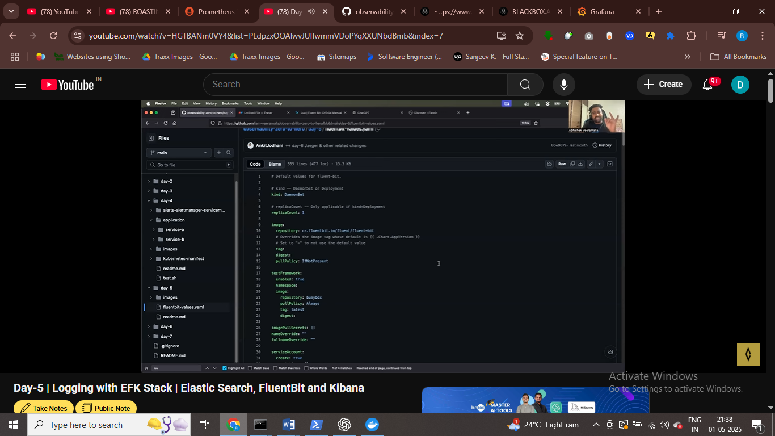

We have flutent bit file that we can define

DAY 6 DISTRUBETED TRACING